**1.a.i) Aim: To design a webpage to demonstrate Physical Formatting Tags.**

**Source code:**

<!DOCTYPE html>

<html>

<head>

<title>Physical Formatting Tags</title>

</head>

<body>

<h1>physical tags</h1><br><br>

<i>Bapatla Engineering college</i><br>

<b> Bapatla Engineering college </b><br>

<u> Bapatla Engineering college </u><br>

<big> Bapatla Engineering college </big><br>

<small> Bapatla Engineering college </small><br>

sub<sub> Bapatla Engineering college </sub>bec<br>

sup<sup> Bapatla Engineering college </sup>bec<br><br><br>

<h2>Logical tags</h2>

<abbr title="Hyper Text Markup Language">HTML</abbr><br>

<dfn title="Cascading Style Sheets">CSS</dfn><br>

<em>em emphasize text</em><br>

<mark>mark is used to highlight the content</mark><br>

akhil <ins>yakkala</ins><br>

some parts of the portion were <del>deleted</del><br>

<strong>strong words</strong><br>

q adds <q>this is </q> very important<br>

4th <blockquote>sem is very important</blockquote><br>

<code>

Print(“hello world”)

</code><br>

<samp> hello world</samp><br>

kbd displays <kbd> akhil</kbd><br>

bdo is used to change the direction of the text from<br><bdo dir="ltr"> left to right</bdo><br> and <bdo dir="rtl"> right to left</bdo><br>

</body>

</html>

**Output:**

**1.b) Aim: To design a Webpage to demonstrate various lists in HTML.**

**Source code:**

<!DOCTYPE html>

<html>

<head>

<title>Types of lists</title>

</head>

<body>

<h3>ordered lists</h3>

<ol>

<li>cats</li>

<li>dogs</li>

<li>wolfs</li>

</ol>

<h3>Unordered lists</h3>

<ul>

<li>Labrador retriever </li>

<li>golden retriever</li>

<li>doberman</li>

<li>pug</li>

</ul>

<h3>Description lists</h3>

<dl>

<dt>persian</dt>

<dd>cat</dd>

<dt>Egyptian</dt>

<dd>cat</dd>

<dt>street</dt>

<dd>cat</dd>

</dl>

</body>

</html>

**Output:**

**1.c) Aim: Design a webpage to create timetable.**

**Source code:**

<!DOCTYPE html>

<html>

<body>

<img align="right" src="capture.png" width="150" height="110">

<img align="left" src="logo.jfif" width="150" height="110">

<h2 align="center">Bapatla Engineering College::bapatla</h2>

<p align="center">(Autonomous)</p>

<p align="center">Department of Information Technology</p>

<p align="center" style="color:red">Class Time Tables for the <mark><u style="color:red">A.Y 2021-22,IV Semester</u></mark></p><hr>

<table border="1">

<pre><p> w.e.f: <b>28-03-2022</b> class:<b> II B.Tech,IT</b> section:<b>A</b> Room No: <b>RPLH-03</b></p></pre>

<tr col style="background-color:orange">

<th>Day</th>

<th>7:30-8:20</th>

<th>8:20-9:10</th>

<th>9:10-10:00</th>

<td rowspan="7" col style="background-

color:orange">break</td>

<th>10:30-11:20</th>

<th>11:20-12:10</th>

<th>12:10-1:00</th>

</tr>

<tr>

<th col style="background-color:orange">Mon</th>

<td align="center">PEHV</td>

<td align="center">DAA</td>

<td align="center">Python Programming</td>

<td align="center">WT</td>

<td align="center">P&S </td>

<td align="center">DBMS</td>

</tr>

<tr>

<th col style="background-color:orange">Tues</th>

<td align="center" colspan="3"><- WT/RDBMS Lab -></td>

<td align="center">DBMS</td>

<td align="center">Python Programming</td>

<td align="center">WT</td>

</tr>

<tr>

<th col style="background-color:orange">Wed</th>

<td align="center">P&S </td>

<td align="center">DAA</td>

<td align="center">WT</td>

<td align="center" colspan="3"><- RDBMS/Python Prog.Lab ></td>

</tr>

<tr>

<th col style="background-color:orange">Thu</th>

<td align="center">PEHV</td>

<td align="center">Python Programming</td>

<td align="center">DBMS</td>

<td align="center">P&S </td>

<td align="center">WT</td>

<td align="center">DAA</td>

</tr>

<tr>

<th col style="background-color:orange">Fri</th>

<td align="center" colspan="3"><- Python Prog./WT Lab -></td>

<td align="center">PEHV</td>

<td align="center">DAA</td>

<td align="center">DBMS</td>

</tr>

<tr>

<th col style="background-color:orange">Sat</th>

<td align="center">DAA</td>

<td align="center">DBMS</td>

<td align="center">P&S </td>

<td align="center">PEHV</td>

<td align="center">WT</td>

<td align="center" style="background-color:green">Mentoring</td>

</tr>

</table>

<pre><p> <mark style="background-color:aqua">Section Coordinator:Mr.K.Suresh Kumar,Asst.Professor</p></pre>

<table>

<tr col style="background-color:orange">

<th>Sub.Code</th>

<th>Sub.Name</th>

<th>Faculty Name</th>

<th>Sub.Code</th>

<th>Sub.Name</th>

<th>Faculty Name</th>

</tr>

<tr>

<th>20IT401/MA03</th>

<td>P&S </td>

<td>Mr.I.Pothuraju</td>

<th>20ITL401</th>

<td>WT Lab</td>

<td>Mr.Sk.Mabasha</td>

</tr>

<tr>

<th>20IT402</th>

<td>WT</td>

<td>Mr.Sk.Mabasha</td>

<th>20ITL402</th>

<td>RDBMS Lab</td>

<td>Mr.P.Ravi Kumar</td>

</tr>

<tr>

<th>20IT403</th>

<td>DBMS</td>

<td>Mr.P.Ravi Kumar</td>

<th>20ITL403/SO02</th>

<td>Python Prog.Lab</td>

<td>Mr.K.Suresh Kumar</td>

</tr>

<tr>

<th>20IT404</th>

<td>DAA </td>

<td>Prof.N.Sivaram Prasad</td>

</tr>

<tr>

<th>MC02</th>

<td>PEHV </td>

<td>Dr.K.Srinivasa Rao</td>

</tr>

</table>

<table border="1"><hr>

<pre><p> w.e.f: <b>28-03-2022</b> class:<b> II B.Tech,IT</b> section:<b>B</b> Room No: <b>RPLH-04</b></p></pre>

<tr col style="background-color:orange">

<th>Day</th>

<th>7:30-8:20</th>

<th>8:20-9:10</th>

<th>9:10-10:00</th>

<td rowspan="7" col style="background-color:orange">break</td>

<th>10:30-11:20</th>

<th>11:20-12:10</th>

<th>12:10-1:00</th>

</tr>

<tr>

<th col style="background-color:orange">Mon</th>

<td align="center" colspan="3"><- WT/RDBMS Lab -></td>

<td align="center">DBMS</td>

<td align="center">DAA</td>

<td align="center">WT</td>

</tr>

<tr>

<th col style="background-color:orange">Tues</th>

<td align="center">PEHV</td>

<td align="center">P&S</td>

<td align="center">Python Programming</td>

<td align="center">WT</td>

<td align="center">DAA</td>

<td align="center">DBMS</td>

</tr>

<tr>

<th col style="background-color:orange">Wed</th>

<td align="center">DAA </td>

<td align="center">DBMS</td>

<td align="center">P&S </td>

<td align="center">Python Programming</td>

<td align="center">WT</td>

<td align="center">PEHV</td>

</tr>

<tr>

<th col style="background-color:orange">Thu</th>

<td align="center">WT</td>

<td align="center">PEHV</td>

<td align="center">DAA</td>

<td align="center" colspan="3"> <- RDBMS/Python Prog.Lab -></td>

</tr>

<tr>

<th col style="background-color:orange">Fri</th>

<td align="center">Python Programming</td>

<td align="center">P&S </td>

<td align="center">DAA</td>

<td align="center">DBMS</td>

<td align="center">WT</td>

<td align="center">PEHV</td>

</tr>

<tr>

<th col style="background-color:orange">Sat</th>

<td align="center" colspan="3"><- Python Prog./WT Lab -></td>

<td align="center">DBMS</td>

<td align="center">P&S </td>

<td align="center" style="background-color:green">Mentoring</td>

</tr>

</table>

<pre><p> <mark style="background-color:aqua">Section Coordinator:Mr.SK.Mabasha,Asst.Professor</p></pre>

<table>

<tr col style="background-color:orange">

<th>Sub.Code</th>

<th>Sub.Name</th>

<th>Faculty Name</th>

<th>Sub.Code</th>

<th>Sub.Name</th>

<th>Faculty Name</th>

</tr>

<tr>

<th>20IT401/MA03</th>

<td>P&S </td>

<td>Mr.N.Karunakar</td>

<th>20ITL401</th>

<td>WT Lab</td>

<td>Mr.Sk.Mabasha</td>

</tr>

<tr>

<th>20IT402</th>

<td>WT</td>

<td>Mr.Sk.Mabasha</td>

<th>20ITL402</th>

<td>RDBMS Lab</td>

<td>Mr.P.Ravi Kumar</td>

</tr>

<tr>

<th>20IT403</th>

<td>DBMS</td>

<td>Mr.P.Ravi Kumar</td>

<th>20ITL403/SO02</th>

<td>Python Prog.Lab</td>

<td>Mr.K.Sai Prasanth</td>

</tr>

<tr>

<th>20IT404</th>

<td>DAA </td>

<td>Prof.P.Ratna Prakash</td>

</tr>

<tr>

<th>MC02</th>

<td>PEHV </td>

<td>Dr.K.Srinivasa Rao</td>

</tr>

</table>

</body>

</html>

**Output:**

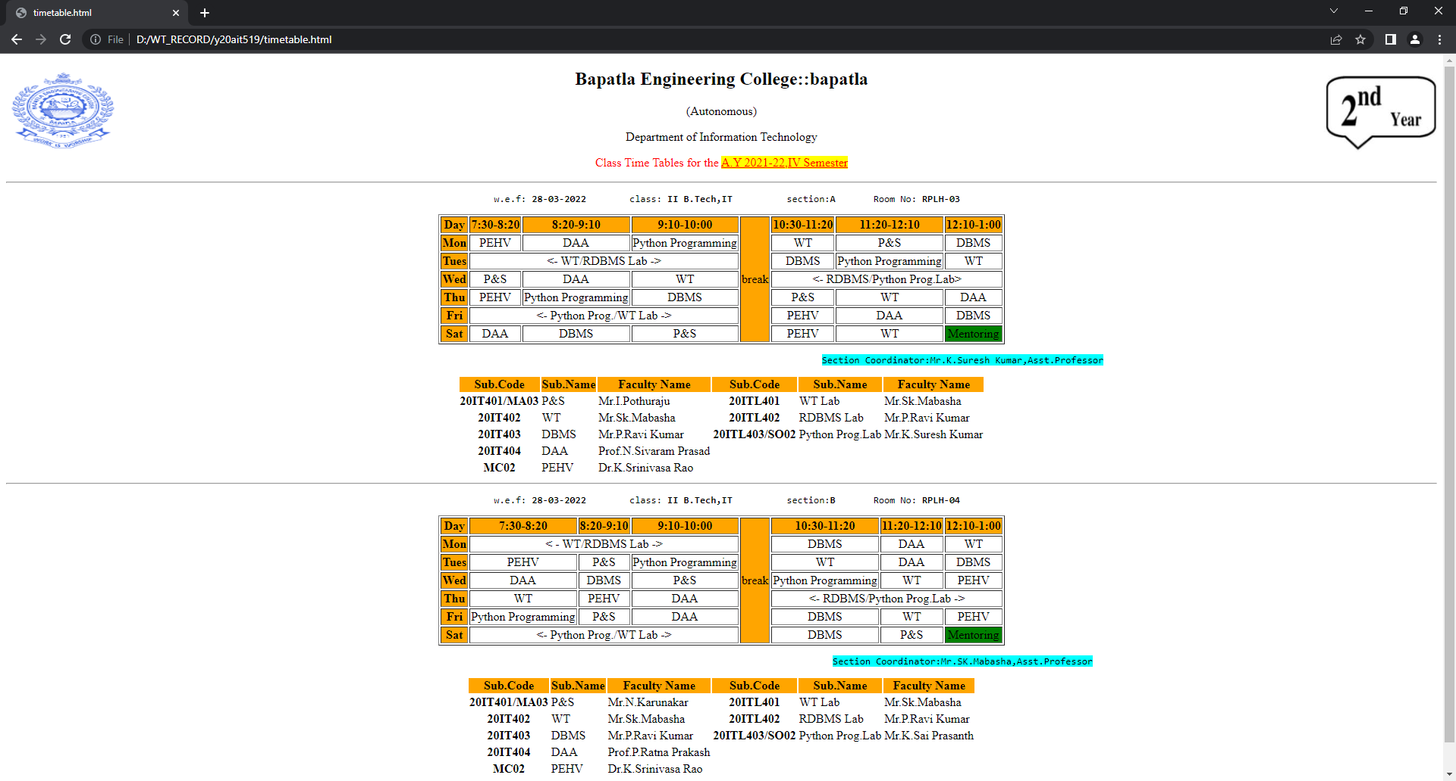

**2.a) Aim: To design a webpage to demonstrate internal link, external link and image as a link.**

**Source code:**

<!DOCTYPE html>

<html>

<head>

<title>Types of links</title>

</head>

<body>

<a href="#bottom">go to bottom</a>

<h3>Internal Link</h3>

<p>used for connecting different sections of a webpage</p>

<a id="top"></a>

<h2>top</h2>

<h2>top</h2>

<h2>top</h2>

<h2>top</h2>

<h2>top</h2>

<h2>top</h2>

<h2>top</h2>

<h2>top</h2>

<h2>top</h2>

<h2>top</h2>

<h2>top</h2>

<h3>External Link</h3>

<p>used to connect different web pages</p>

<a href="http://becbapatla.ac.in">BEC</a>

<h3>Image Link</h3>

<p>using image as link</p>

<a href="http://www.google.com"><img src="nature.jpg" width="100" height="100"/></a><br><br>

<a href="#top">go to top</a>

<a id="bottom"></a>

</body>

</html>

**Output:**

**Internal link:**

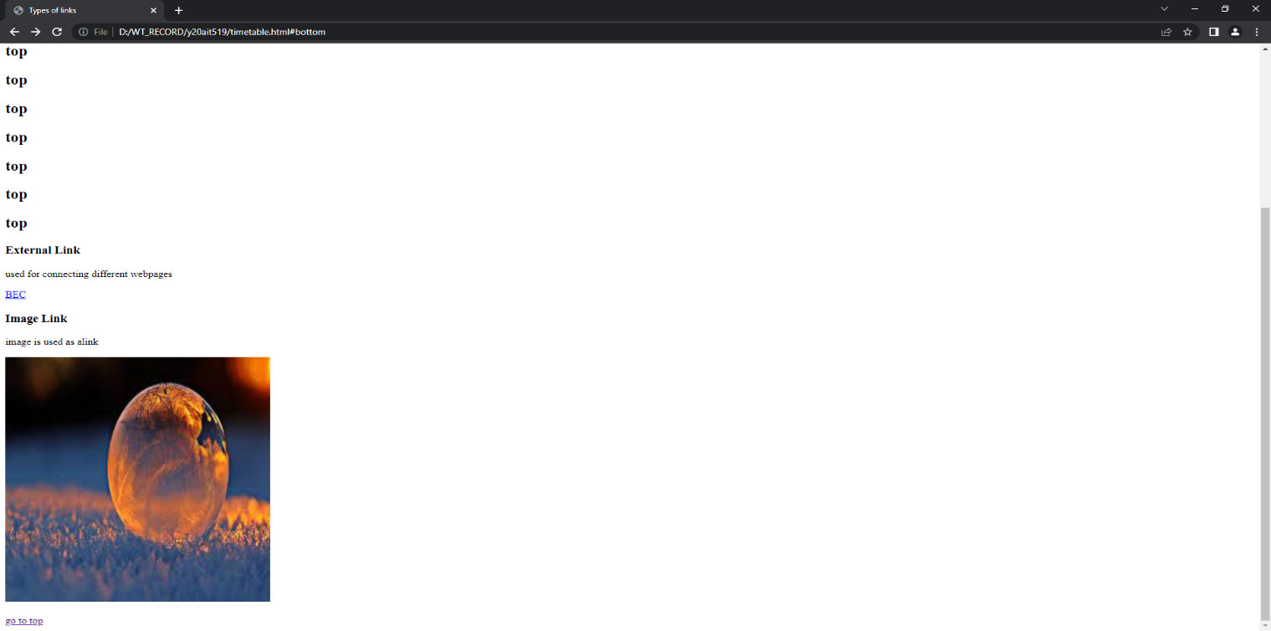

**External link:**

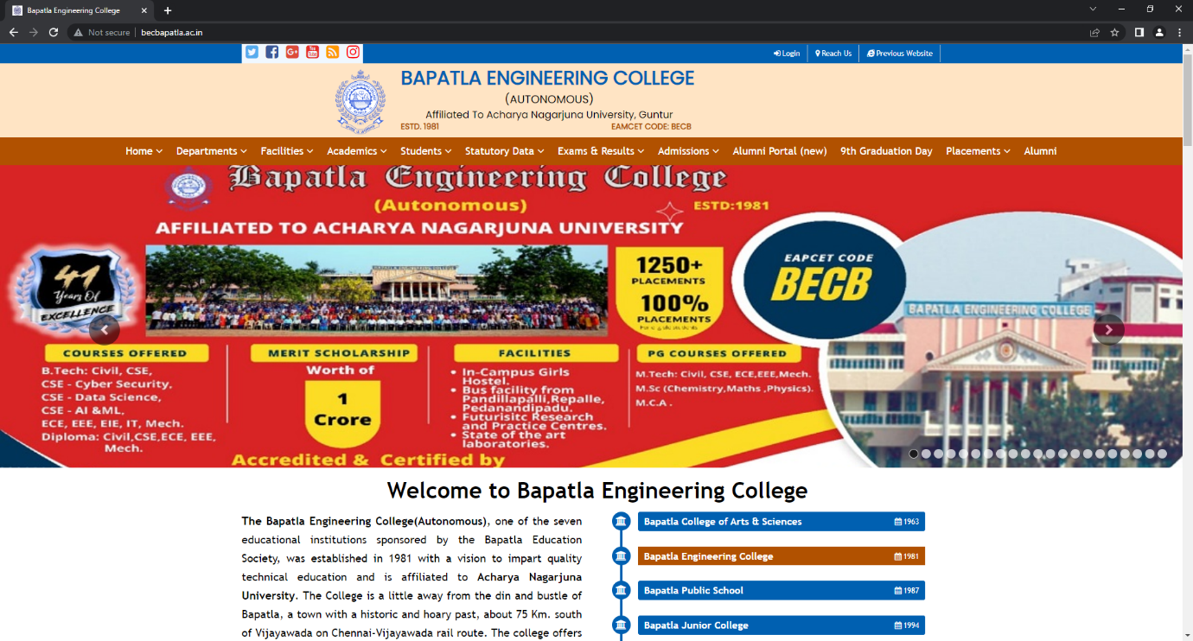

**Image as link:**

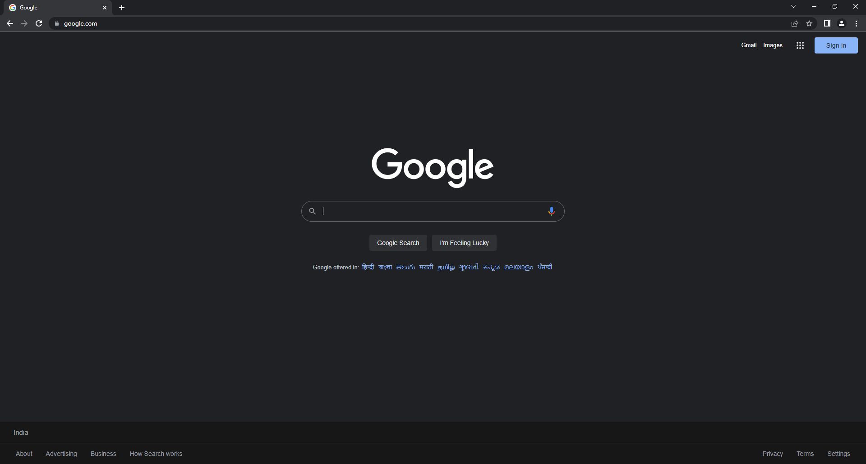

**2.b)**

**Aim: To design a webpage to demonstrate Id tag using frames.**

**Source code:**

<!DOCTYPE html>

<html>

<head>

<title></title>

</head>

<frameset rows="20%,80%" border="2">

<frame name="header" src="1.html">

<frameset cols="50%,50%">

<frame name="aside" src="2.html">

<frame name="section">

</frameset>

</frameset>

</html>

**1.html:**

<!DOCTYPE html>

<html>

<body>

<h1>Welcome to Frames<h1>

</body>

<html>

**2.html:**

<!DOCTYPE html>

<html>

<body>

<h3>Click the link to display</h3>

<a href="list.html" target="section">Lists</a><br><br>

<a href="link.html" target="section">Links</a>

</body>

<html>

**Output:**

**When clicked on Lists:**

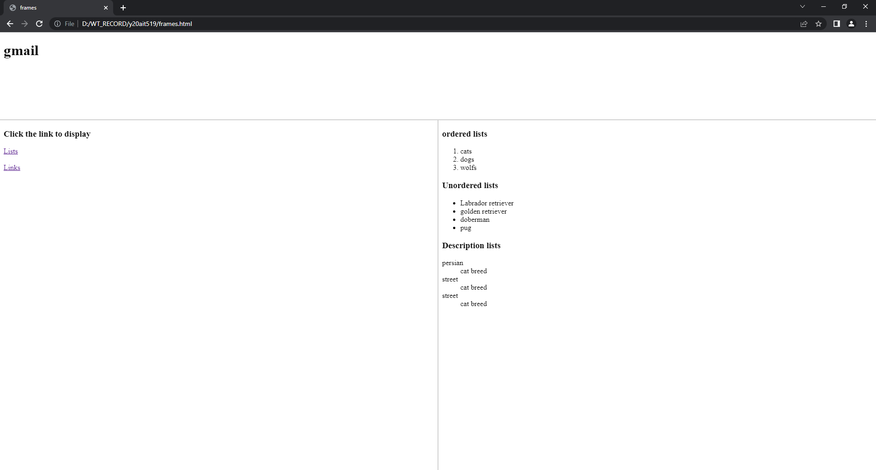

**When clicked on Links:** 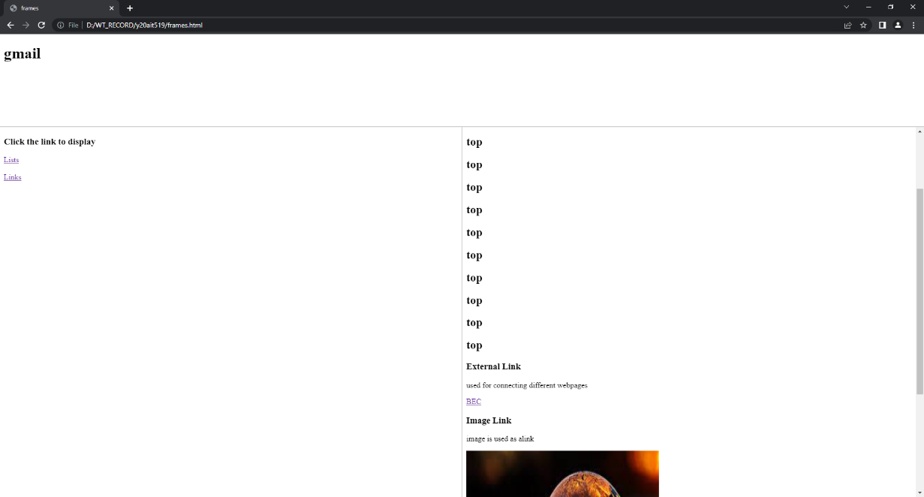

**2.c) Aim:** **Design a webpage to demonstrate image map creation.**

**Source code:**

<!DOCTYPE html>

<html>

<head>

<title>image map</title>

</head>

<body>

<h1>INDIA</h1>

<img src="Indiamap.jpg" usemap="#India">

<map name="India">

<area shape="circle" coords="210,510,30" href="https://ap.nic.in/">

<area shape="circle" coords="210,450,30" href="https://tsonline.gov.in/TGPortal/Index.aspx">

<area shape="circle" coords="270,370,40" href="https://chhattisgarh.nic.in/">

<area shape="circle" coords="300,370,50" href="https://odisha.gov.in/">

<area shape="circle" coords="150,510,30" href="https://www.karnataka.gov.in/english">

<area shape="circle" coords="125,420,50" href="https://maharashtra.gov.in/1125/Home">

<area shape="circle" coords="180,600,20" href="https://keralacm.gov.in/">

<area shape="circle" coords="210,600,30" href="https://www.tn.gov.in/">

<area shape="circle" coords="210,350,40" href="https://mp.gov.in/">

<area shape="circle" coords="100,350,40" href="https://gujaratindia.gov.in/">

<area shape="circle" coords="100,250,40" href="https://rajasthan.gov.in/">

<area shape="circle" coords="250,250,40" href="https://up.gov.in/en">

<area shape="circle" coords="330,250,40" href="https://state.bihar.gov.in/main/CitizenHome.html">

<area shape="circle" coords="350,290,40" href="https://www.jharkhand.gov.in/">

<area shape="circle" coords="400,320,20" href="https://wb.gov.in/">

<area shape="circle" coords="390,250,30" href="https://meghalaya.gov.in/">

<area shape="circle" coords="400,200,40" href="https://sikkim.gov.in/">

<area shape="circle" coords="470,220,40" href="https://assam.gov.in/">

<area shape="circle" coords="550,200,20" href="https://www.arunachalpradesh.gov.in/">

<area shape="circle" coords="550,230,20" href="https://nagaland.gov.in/">

<area shape="circle" coords="550,270,20" href="https://manipur.nic.in/">

<area shape="circle" coords="510,300,20" href="https://mizoram.gov.in/">

<area shape="circle" coords="490,300,20" href="https://tripura.gov.in/">

<area shape="circle" coords="220,200,40" href="https://uk.gov.in/">

<area shape="circle" coords="150,500,30" href="https://www.goa.gov.in/">

</map>

</body>

</html>

**Output:**

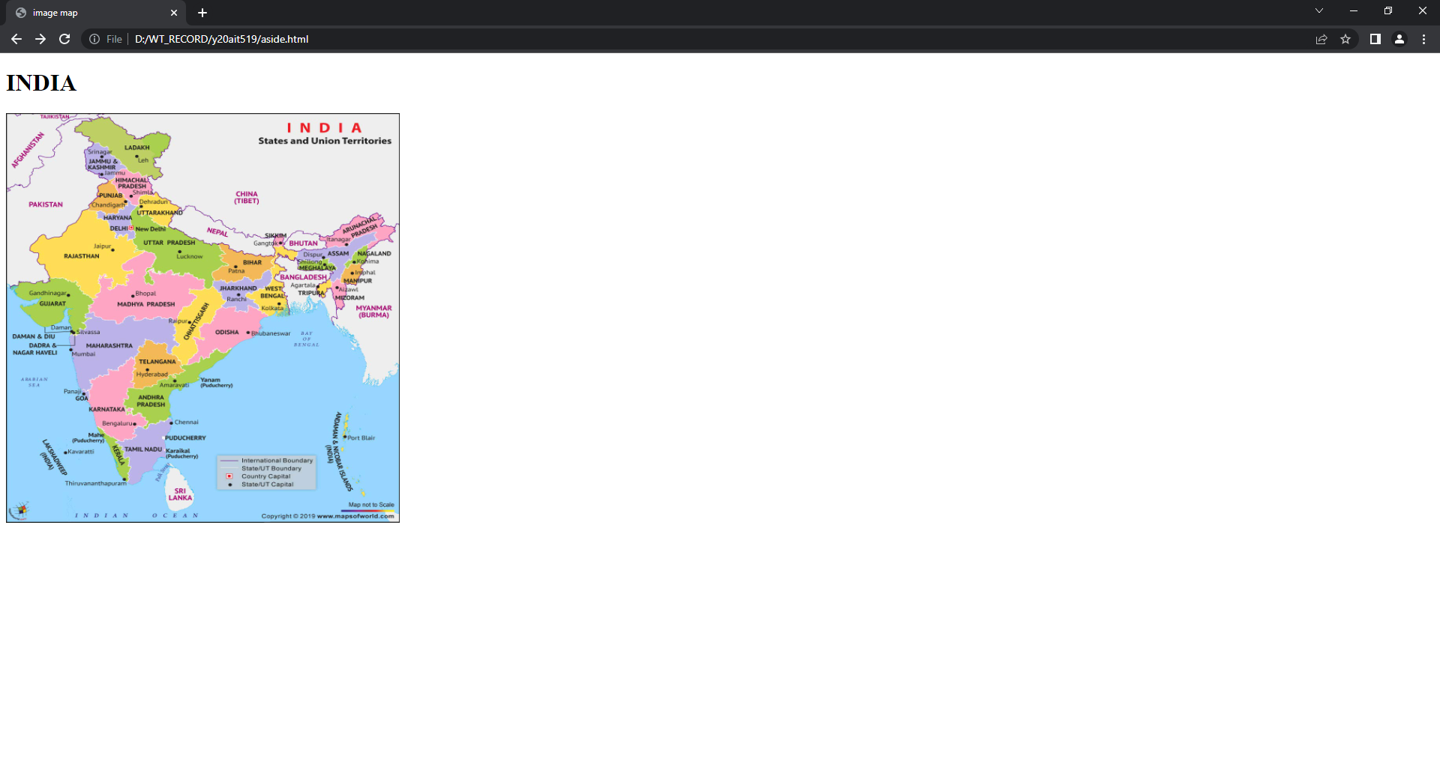

**When clicked on Andhra Pradesh,Ap website is opened**

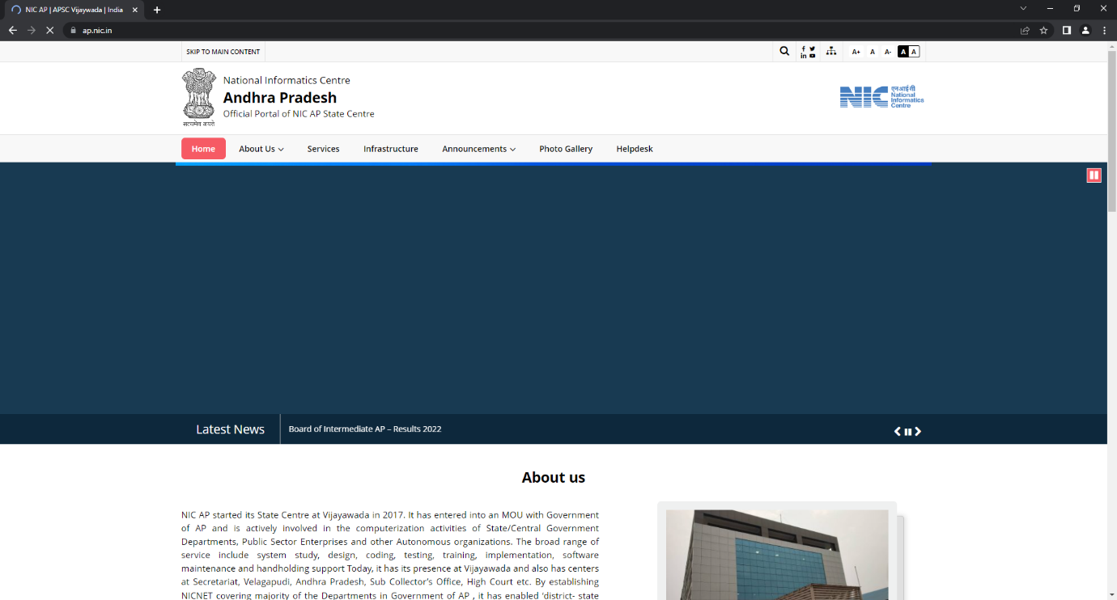

**When we click on kerala, kerala website is opened.**

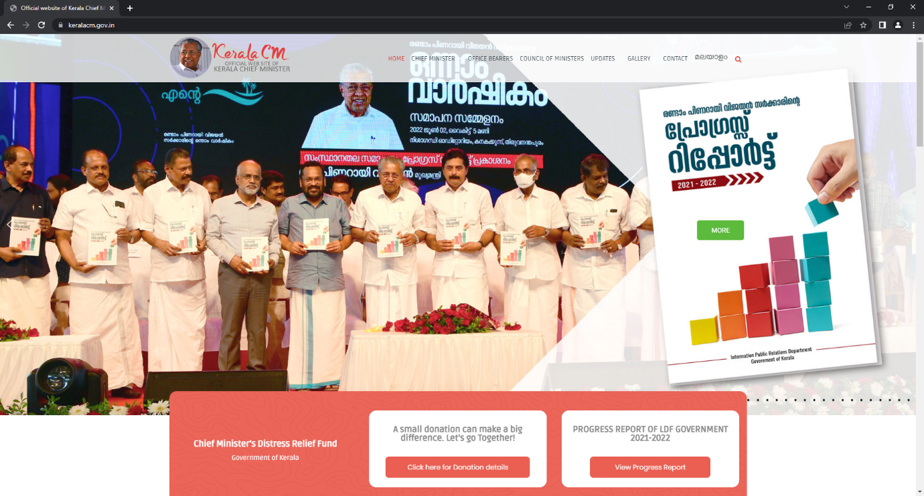

**3.a) Aim: To design an HTML document to create registration form using all input fields.**

**Source code:**

<!DOCTYPE html>

<html>

<head>

<title>Form</title>

</head>

<body >

<fieldset>

<div style=”width:30%”>

<form>

<fieldset style="background-color:cyan">

<h1 align="center">Student Registration Form</h1>

</fieldset>

<fieldset style="background-color:cyan">

<label>Name:</label>

<input type="text" placeholder="Enter full name" max-size="20"><br><br>

<label>Father's Name:</label>

<input type="text" max-size="20"><br><br>

<label>Mother's Name:</label>

<input type="text" max-size="20"><br><br>

<label>Phone Number:</label>

<input type="tel" placeholder="017xxxxxxx" max-size="10"><br><br>

<label>Email:</label>

<input type="email" placeholder="sample@example.com"><br><br>

<label>Password:</label>

<input type="password"><br><br>

<label>Gender:</label>

<input type="radio" name="gender" value="Male">Male

<input type="radio" name="gender" value="Female">Female

<input type="radio" name="gender" value="Other">Other<br><br>

<label>Date of Birth</label>

<input type="date"><br><br>

<label>Address</label>

<input type="text" placeholder="Street:- House:- Road:-"><br><br>

<label>Blood Group:</label>

<select>

<option>select</option>

<option>B+</option>

<option>B-</option>

<option>O+</option>

<option>O-</option>

</select><br><br>

<label>Department:</label>

<input type="radio" name="Department" >IT

<input type="radio" name="Department" >CSE

<input type="radio" name="Department" >EEE<br><br>

<label>Course:</label>

<input type="checkbox" name="Course" >C++

<input type="checkbox" name="Course" >JAVA

<input type="checkbox" name="Course" >Python<br><br>

<label>Photo:</label>

<input type="file"><br><br>

<input type="submit">

<input type="reset">

</form>

</fieldset>

</div>

</fieldset>

</body>

</html>

**OUTPUT:**

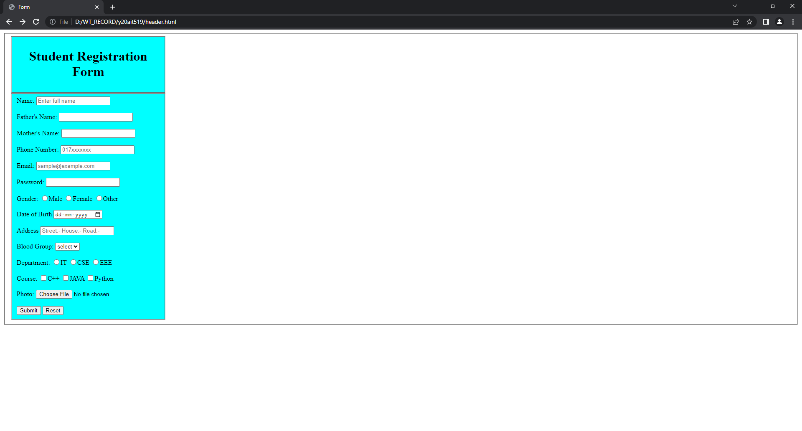

**3.b) Aim: Write an html document to create a form that demonstrate label, textarea, select ,legend ,option ,option group , fieldset.**

**Source code:**

<!DOCTYPE html>

<html>

<head>

<title>Form Elements</title>

</head>

<body>

<h2>Form Elements</h2>

<h3>Label</h3>

<label>Name</label>

<input type="text"/>

<h3>Text Area</h3>

<textarea rows="5" cols="50">Add a comment...</textarea>

<h3>Option</h3>

<select>

<option>ML</option>

<option>IOT</option>

<option>WEB 3.0</option>

<option>OS DESIGN</option>

</select>

<h3>Option Group</h3>

<select>

<optgroup label="DOGS">

<option>LABRADOR RETRIVER</option>

<option>DOBERMAN</option>

<option>GERMAN SHEPARD</option>

</optgroup>

<optgroup label="WOLFS">

<option>SIBERIAN</option>

<option>FOX</option>

<option>JUNGLE</option>

</optgroup>

</select><br>

<h3>Fieldset and Legend</h3>

<fieldset>

<legend>Personal Information</legend>

REGD NO:<input type="text"><br>

NAME:<input type="text"><br>

ROLLNO:<input type="text"><br>

</fieldset>

</body>

</html>

**Output:**

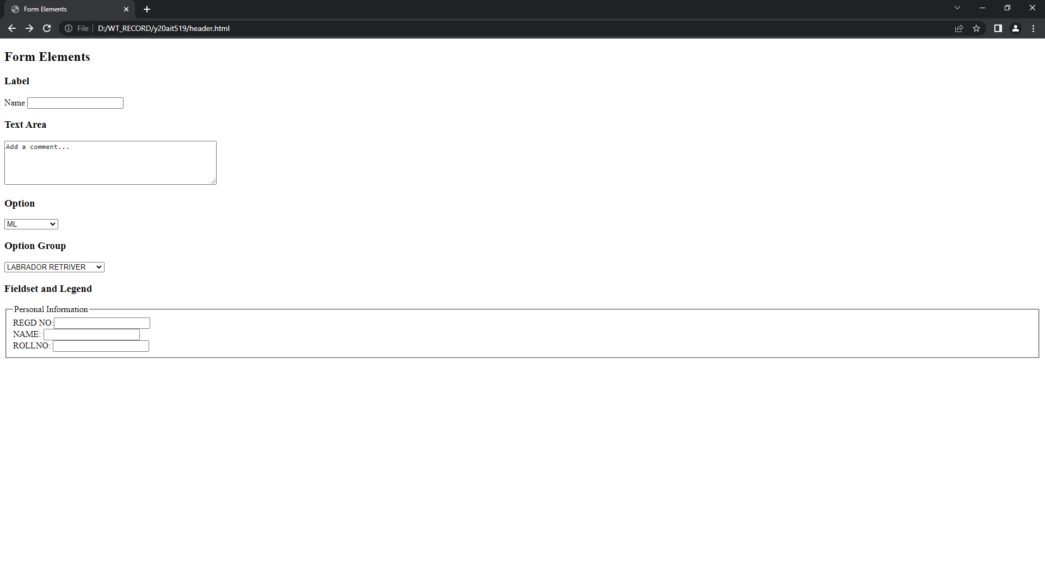

**­­**

**4.a.i) Aim:** **Design a webpage to demonstrate Inline Style sheet.**

**Source code:**

<!DOCTYPE html>

<html>

<head>

<title>inline style sheets</title>

</head>

<body>

<h1 style="color:white;background-color:#0000ff">Cascading style sheets</h1>

<h3 style="font-size:30px;background-color:lavenderblush" >Inline styles </h3>

</body>

</html>

**Output:**

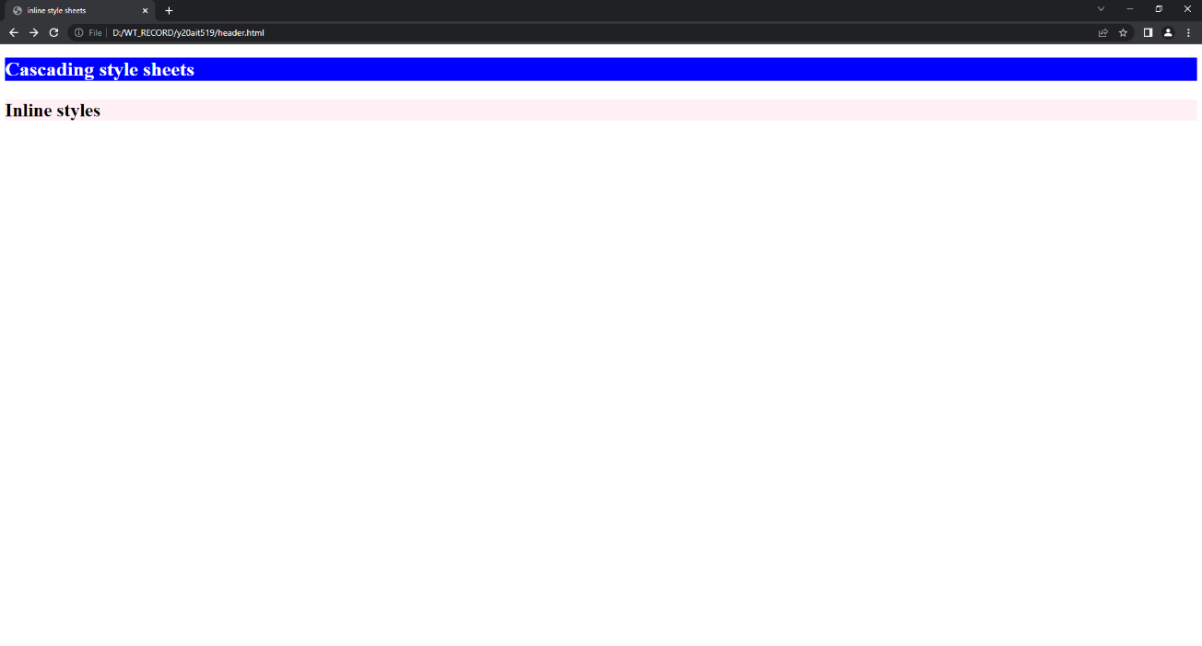

**4.a.ii) Aim:** **Design a webpage to demonstrate Internal Style Sheet.**

**Source code:**

<!DOCTYPE html>

<html>

<head>

<title>internal style sheets</title>

<style>

h1{font-size:20;background:red;}

h3{background-color:black;}

p{font-size:20px;}

</style>

</head>

<body>

<h1>Cascading style sheets</h1>

<h3>Internal styles </h3>

<p>Internal style sheets are used to style the webpages in the html by using style tag in head tag</p>

</body>

</html>

**Output:**

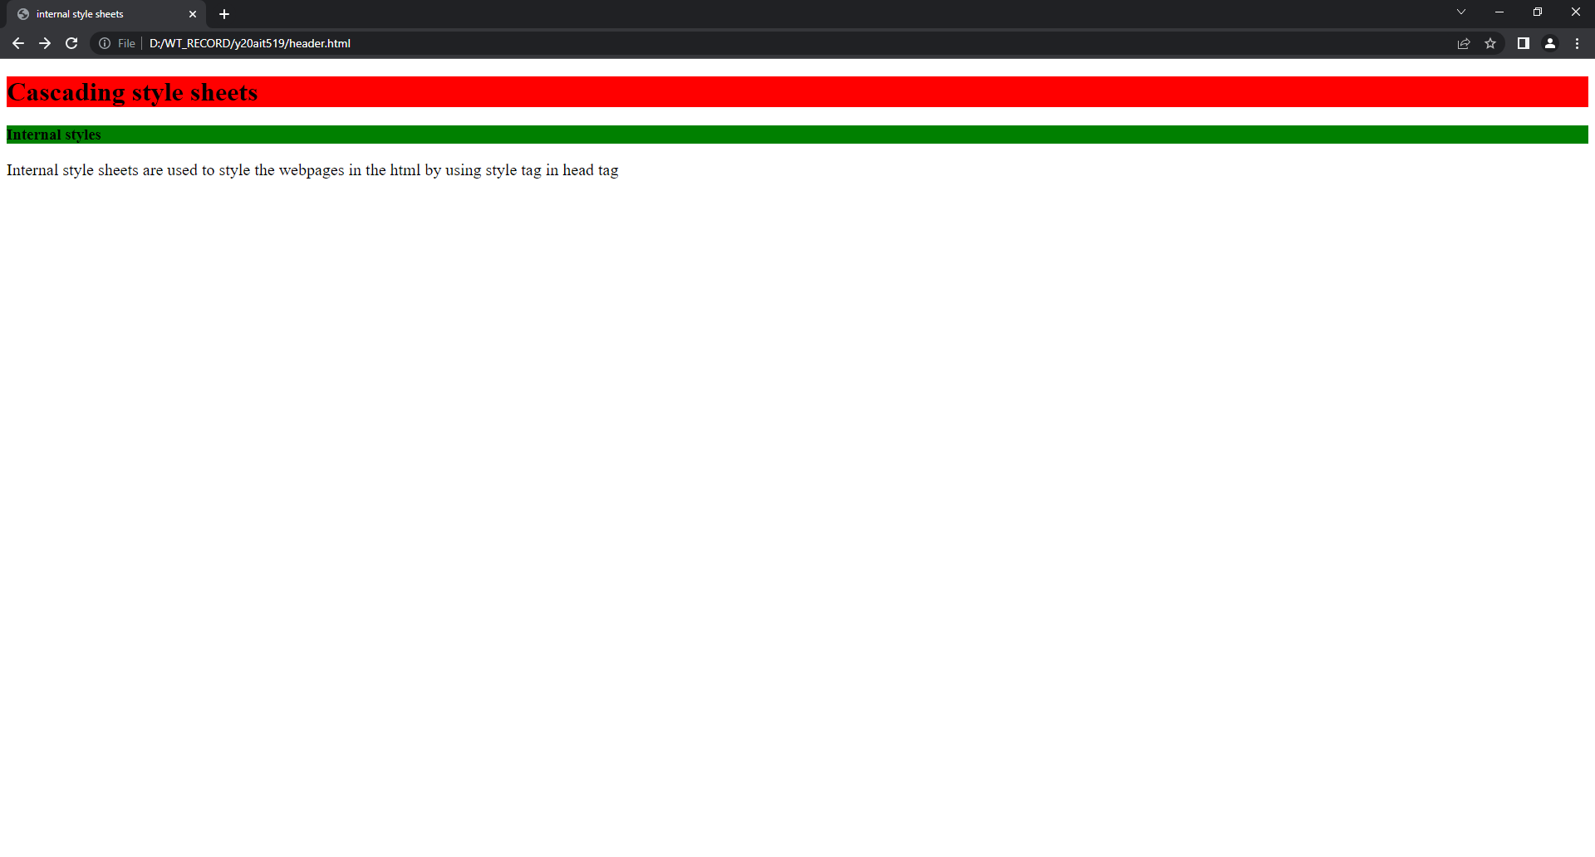

**4.a.ii) Aim:** **Design a webpage to demonstrate External Style Sheet.**

**Source code:**

<!DOCTYPE html>

<html>

<head>

<title>External style sheets</title>

<link rel="stylesheet" type="text/css" href="style.css"/>

</head>

<body>

<h1>Cascading style sheets</h1>

<h3>External styles </h3>

<p>External style sheets are used to style the webpages in the html by creating a css file and linking the css file to the html file using link element in the head</p>

</body>

</html>

EXTERNAL CSS:

h1

{

Background-color:red;

Font-size:30px;

}

P

{

Background-color:green;

Fonr-size:30px;}

**Output:**

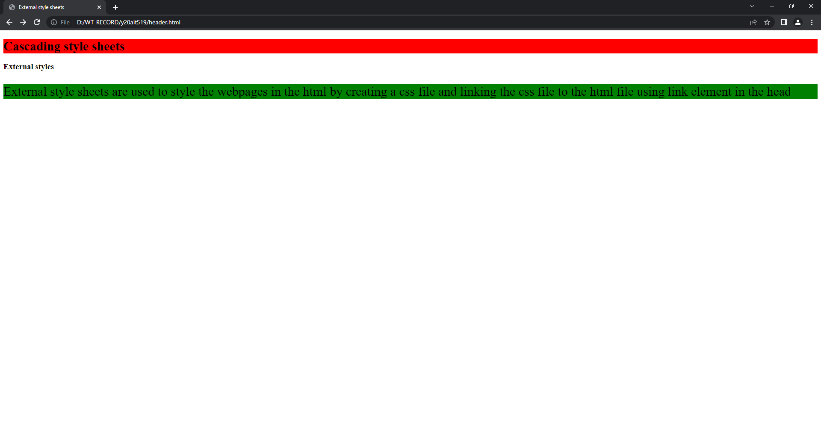

**4.b) Aim: Write a JavaScript program to demonstrate query selector and query selector all.**

**Source code:**

<!DOCTYPE html>

<html>

<head>

<title>Query Selector</title>

<script>

function change(){

document.querySelector("p").style.background="green";

}

function changeall(){

list=document.querySelectorAll("p");

for(var i=0;i<list.length;i++){

list[i].style.backgroundColor="red";}

}

</script>

</head>

<body>

<p>Paragraph 1</p>

<p>Paragraph 2</p>

<p>Paragraph 3</p>

<p>Paragraph 4</p>

<button onclick="change()">selector</button>

<button onclick="changeall()">selector all</button>

</body>

</html>

**Output:**

**Query selector:**

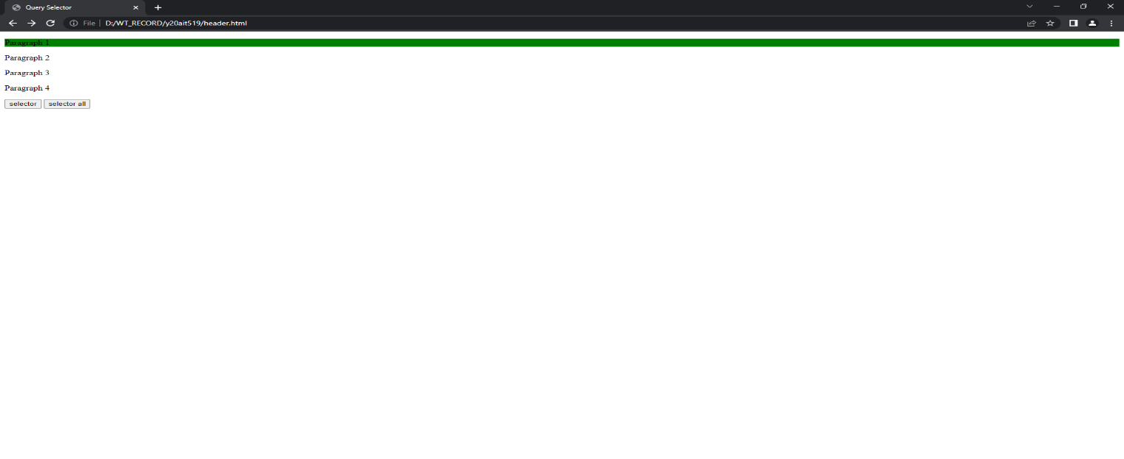

**Query selector all:**

**5. i ) Aim: To write a JavaScript program to demonstrate Form events.**

**Source code:**

<!DOCTYPE html>

<html>

<head>

<title>Form events</title>

<script type="text/javascript">

function focus1(){

document.getElementById("name").style.background="red";

}

function blur2(){

document.getElementById("name").style.background="green";

}

function change2(){

alert("you are changing the content");

}

function invalid2(){

document.getElementById("msg").innerHTML="you cannot

submit the form";

}

function submit2(){

alert("you are submitting the form");

}

function reset2(){

alert("you are resetting the form");

}

</script>

</head>

<body>

<h1>Form Events<h1>

<form onsubmit="submit2()" onreset="preset2()">

<label>enter username:</label>

<input type="text" id="name" oninvalid="invalid2()" onfocus="focus2()" onblur="blur2()" onchange="change2()"><br>

<p id="msg"></p><br>

<input type="submit">

<input type="reset">

</form>

</body>

</html>

**Output:**

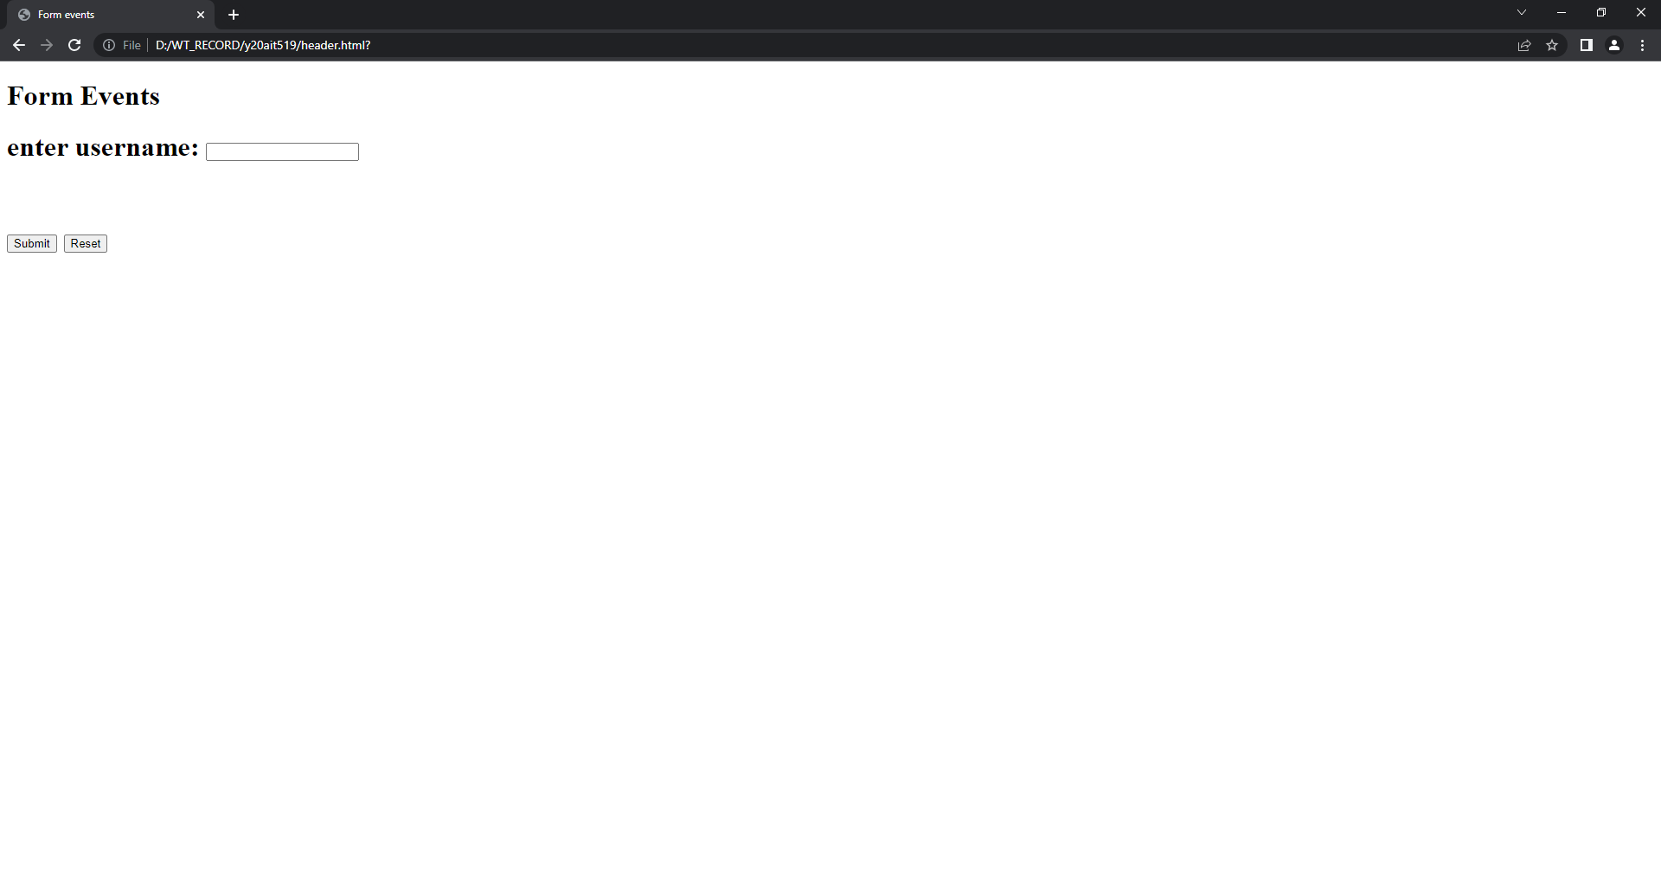

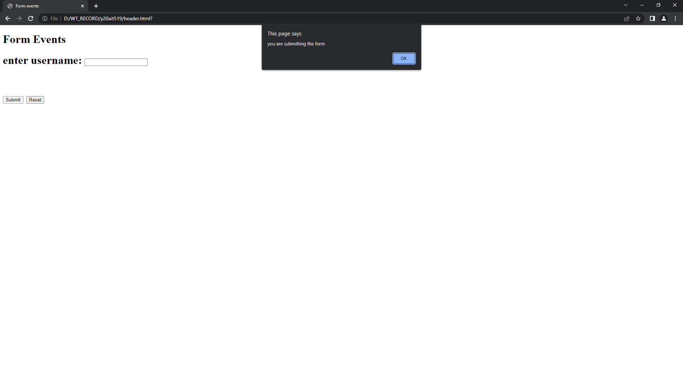

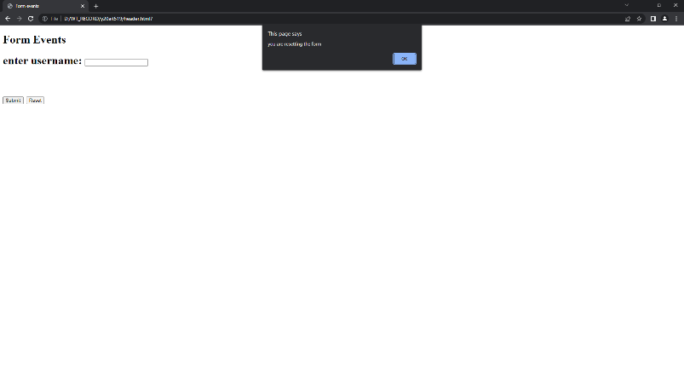

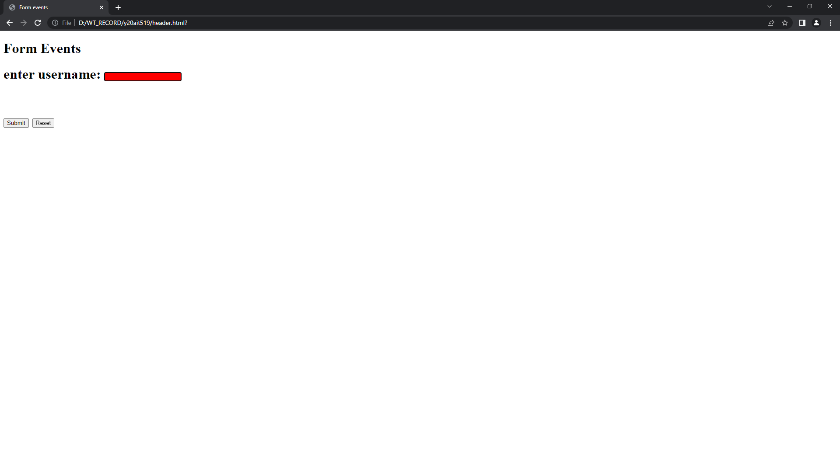

**5. ii ) Aim: Write a JavaScript program to demonstrate Mouse Events.**

**Source code:**

<!DOCTYPE html>

<html>

<head>

<title>Mouse events</title>

<script type="text/javascript">

function mousemove()

{

document.getElementById("click").innerHTML="hello";

}

function mouseclick(){

document.getElementById("click").style.background="black";

}

function mousedblclick(){

document.getElementById("click").style.background="green";

}

function mousedown(){

document.getElementById("down").style.background="green";

}

function mouseup(){

document.getElementById("down").style.background="aqua";

}

function mouseover(img){

img.style.width="300px";

img.style.height="300px";

}

function mouseout(img){

img.style.width="50px";

img.style.height="50px";

}

</script>

</head>

<body>

<h1>Mouse Events<h1>

<button id="click" onclick="mouseclick()" ondblclick="mousedblclick()">click here</button>

<input type=”text ” id="down" onmousedown="mousedown()" onmouseup="mouseup()" onmousemove=”mousemove()”>click here to change the background</input>

<img src="bec.jpg" width="50px" height="50px" onmouseover="mouseover(this)" onmouseout="mouseout(this)">

</body>

</html>

**Output:**

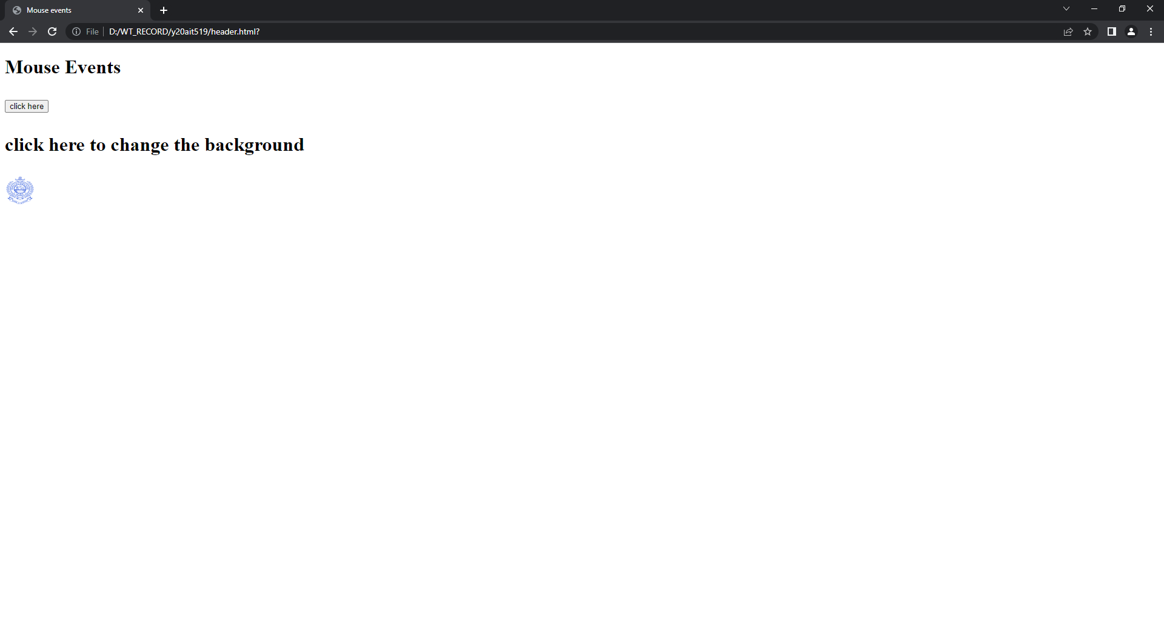

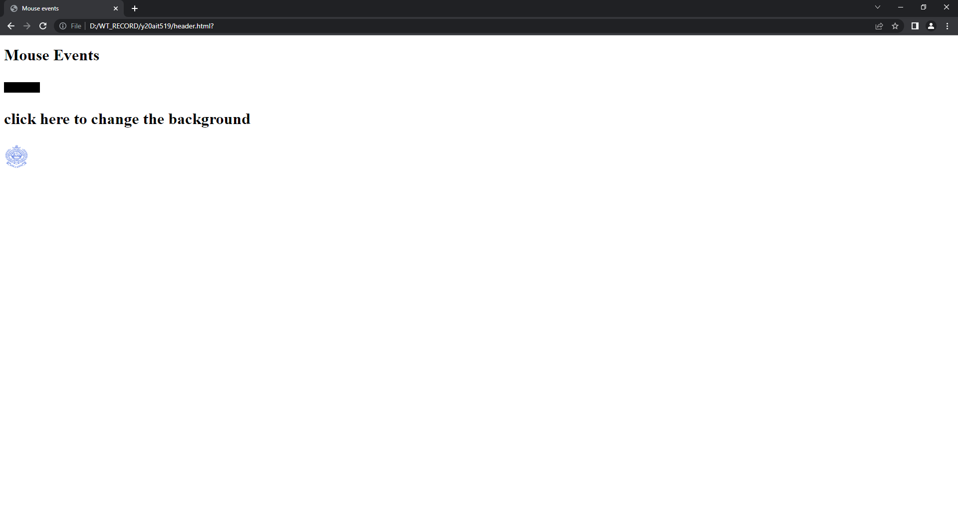

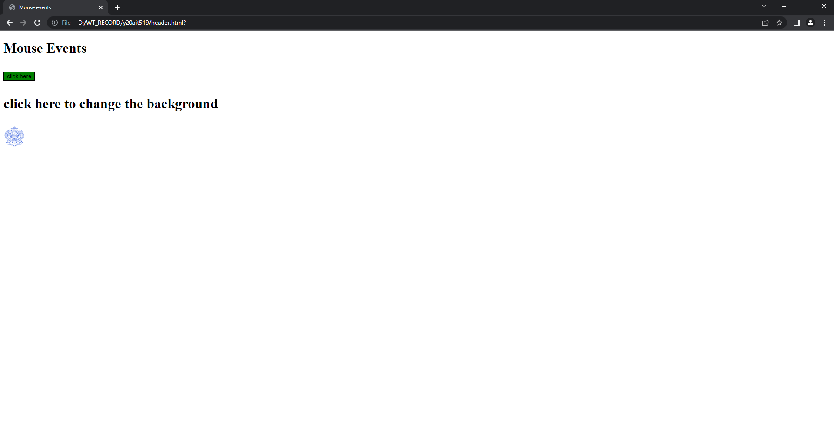

**5. iii) Aim: Write a JavaScript program to demonstrate Pop-up Windows.**

**Source code:**

<!DOCTYPE html>

<html>

<head>

<title>popup boxes</title>

<script type="text/javascript">

function alertmsg(){

alert("This is alert message"); }

function confirmmsg(){

confirm("Are you sure you want to confirm?");

}

function promptmsg(){

var msg = prompt("Please enter message");

document.getElementById("msg").innerHTML="Your message: "+msg;

}

</script>

</head>

<body>

<h1>Demonstrate the popup boxes</h1>

<button onclick="alertmsg()">Alert Box</button><br><br>

<button onclick="confirmmsg()">Confirm Box</button><br><br>

<button onclick="promptmsg()">Prompt Box</button><br>

<p id="msg"></p>

</body>

</html>

**Output:**

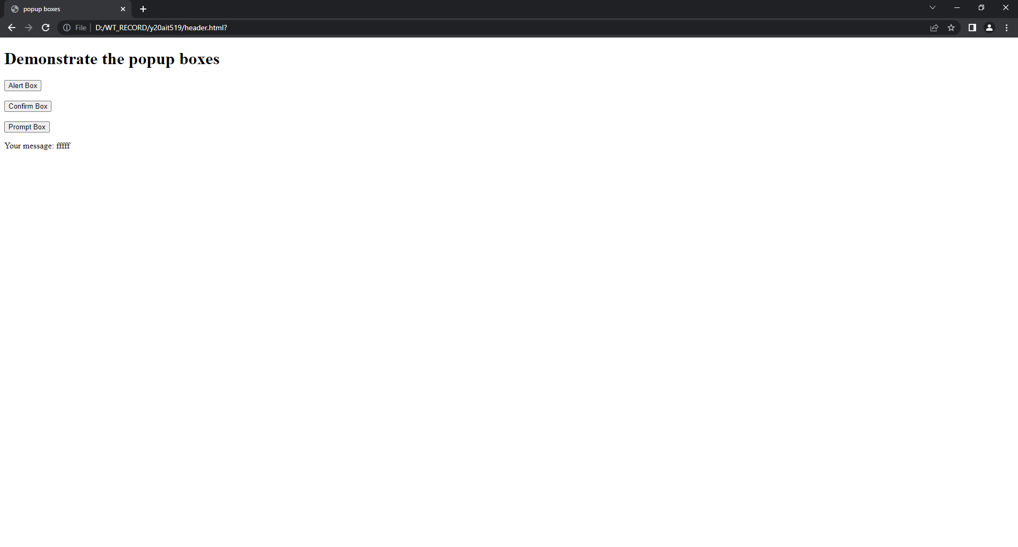

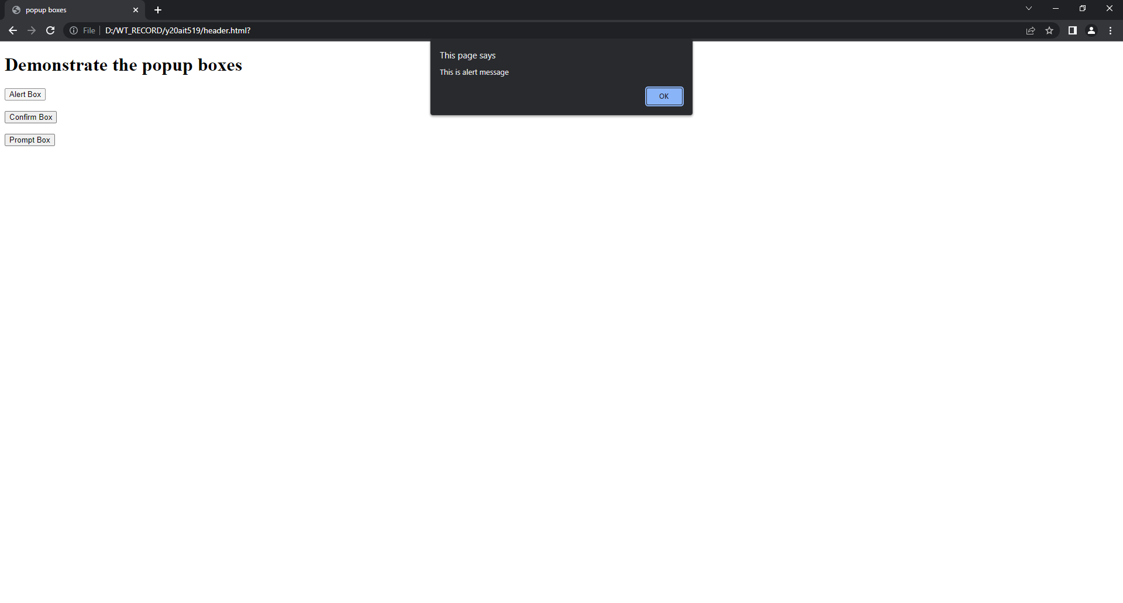

**6. i) Aim**: To **write a JavaScript program to demonstrate String Object.**

**Source code:**

<!DOCTYPE html>

<html>

<head>

<title>String Object</title>

</head>

<body>

<script type="text/javascript">

document.write("<h2>String Objects </h2>");

var s1="welcome to Mr. Sai Akhil";

var s2="welcome to Mr. Yakkala";

document.write("length if s1 is "+ s1.length);

document.write("<br>character at 5th position is "+s1.charAt(5));

document.write("<br>concatination: "+s1.concat(s2));

document.write("<br>index of m is "+s1.indexOf('m'));

document.write("<br>last index of m is "+s1.lastIndexOf('m'));

document.write("<br>slice: "+s1.slice(11,16));

document.write("<br>uppercase: "+s1.toUpperCase());

document.write("<br>lowercase: "+s2.toLowerCase());

document.write("<br>slice: "+s1.slice(" "));

</script>

</body>

<html>

**Output:**

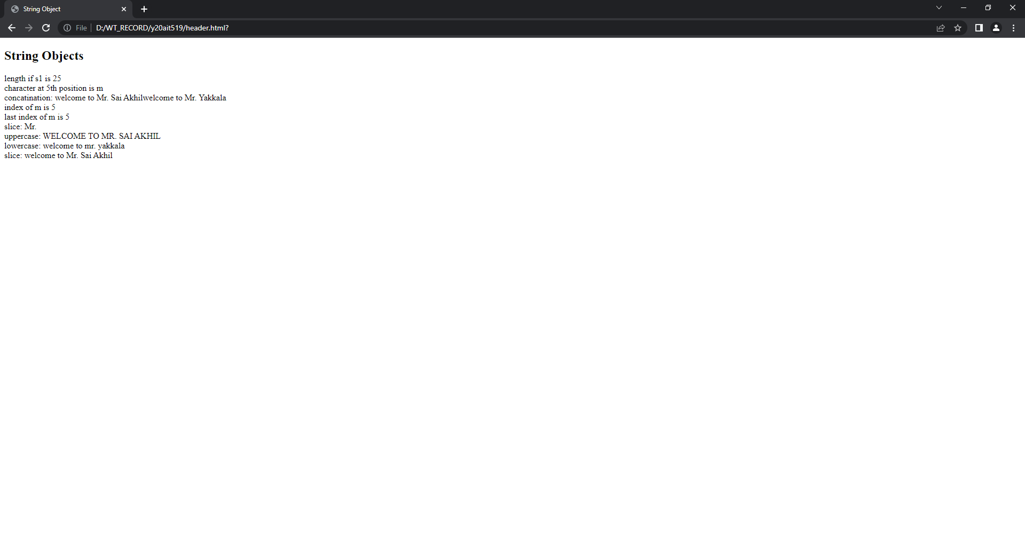

**6.ii) Aim**: **Write a JavaScript program to demonstrate Math Object.**

**Source code:**

<!DOCTYPE html>

<html>

<head>

<title>Math Object</title>

</head>

<body>

<script>

document.write("<h2>Math object properties</h2>");

document.write("Euler's number is :"+Math.E);

document.write("<br>natural logarithmic of 2:"+Math.LN2);

document.write("<br>natural logarithmic of 10:"+Math.LN10);

document.write("<br>base-10 logarithmic of E:"+Math.LOG10E);

document.write("<br>Number value of Pl:"+Math.PI);

document.write("<h2>Math object methods</h2>");

document.write("<br>the value of 5 to the power of 2:"+Math.pow(5,2));

document.write("<br>random number between 0 and 1:"+Math.random());

document.write("<br>square root of 16:"+Math.sqrt(16));

</script>

</body>

</html>

**Output:**

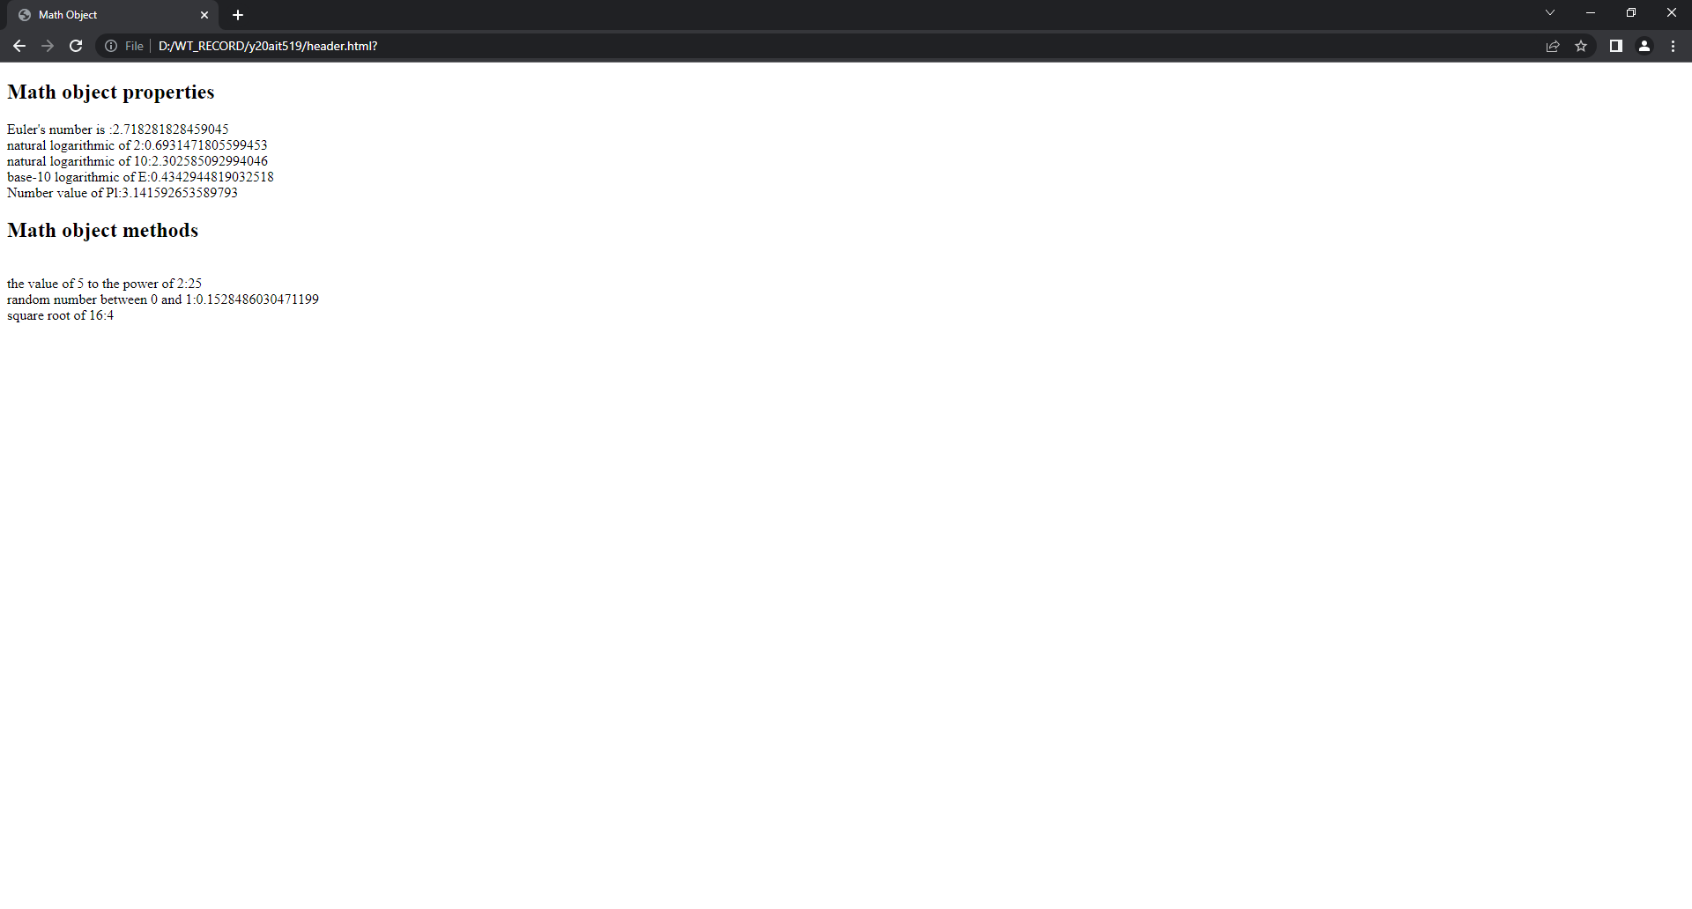

**6.iii) Aim**: To **write a JavaScript program to demonstrate Date Object.**

**Source code:**

<!DOCTYPE html>

<html>

<head>

<title>Date objects</title>

</head>

<body>

<script type="text/javascript">

var d1=new Date();

var d2=new Date(9000000);

var d3=new Date("November 27 2004");

var d4=new Date(2016,11,27);

var d5=new Date(2015,11,24,08,04,59);

document.write("<h2>Date Object</h2>");

document.write("Empty date:"+d1);

document.write("<br> date with milliseconds:"+d2);

document.write("<br> date with string:"+d3);

document.write("<br> date with specified date:"+d4);

document.write("<br> date with specified date and time:"+d5);

document.write("<h2>Date object methods</h2>");

document.write("Current Date:"+Date(d1.valueOf()));

document.write("<br>Day:"+d1.getDay());

document.write("<br>Date:"+d1.getDate());

document.write("<br>Month:"+d1.getMonth());

document.write("<br>Full year:"+d1.getFullYear());

document.write("<br>Hours:"+d1.getHours());

document.write("<br>Minutes:"+d1.getMinutes());

document.write("<br>Seconds:"+d1.getSeconds());

document.write("<br>Milliseconds:"+d1.getMilliseconds());

document.write("<br>time:"+Date(d1.getTime));

document.write("<br>difference between UTC time and local time, in minutes :"+d1.getTimezoneOffset());

document.write("<br>Setting the Date:"+d1.setDate(10));

document.write("<br>get date:"+d1.getDate());

</script>

</body>

</html>

**Output:**

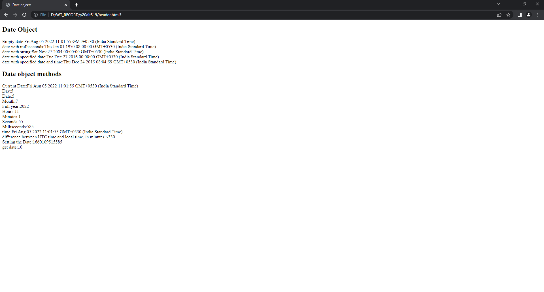

**7. i) Aim: To write a JavaScript program to demonstrate Window object.**

**Source code:**

<!DOCTYPE html>

<html>

<head>

<title>Window object</title>

</head>

<body>

<h2>Window Object Properties</h2>

<script>

document.write("innerWidth:"+window.innerWidth);

document.write("<br>innerHeight:"+window.innerHeight);

document.write("<br>outerWidth:"+window.outerWidth);

document.write("<br>outerHeight:"+window.outerHeight);

document.write("<br>Location:"+window.location);

document.write("<br>Browser name:"+window.navigator.appName);

document.write("<br>Browser Platform:"+window.navigator.platform);

document.write("<br>Screen Height:"+window.screen.height);

document.write("<h2>Window Object Methods<h2>");

function alertmsg(){

alert("Hello! I am an alert box");

}

function openwindow(){

win=window.open(" ", " ",width="5px",height="5px");

}

function closewindow(){

win.close();

}

function focuswindow(){

win.focus();

}

function blurwindow(){

win.blur();

}

function time()

{

document.write("Its been 10sec since you opened this window");

}

t=setTimeout(time,10000)

</script>

<button onclick="alertmsg()">Click here</button>

<button onclick="openwindow()">Open</button>

<button onclick="closewindow()">Close</button>

<button onclick="window.print()">Print</button>

<button onclick="focuswindow()">Focus</button>

<button onclick="blurwindow()">Blur</button>

</body>

</html>

**Output:**

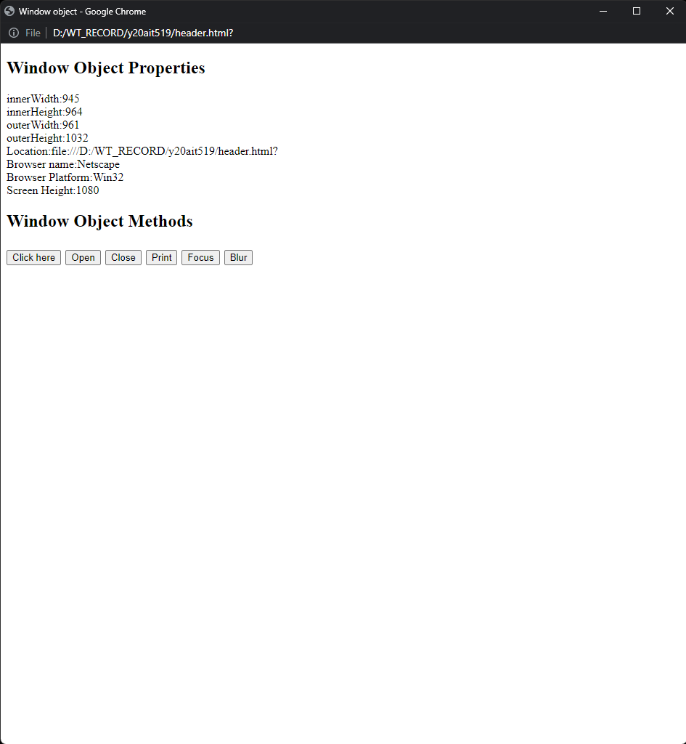

**Alert box:**

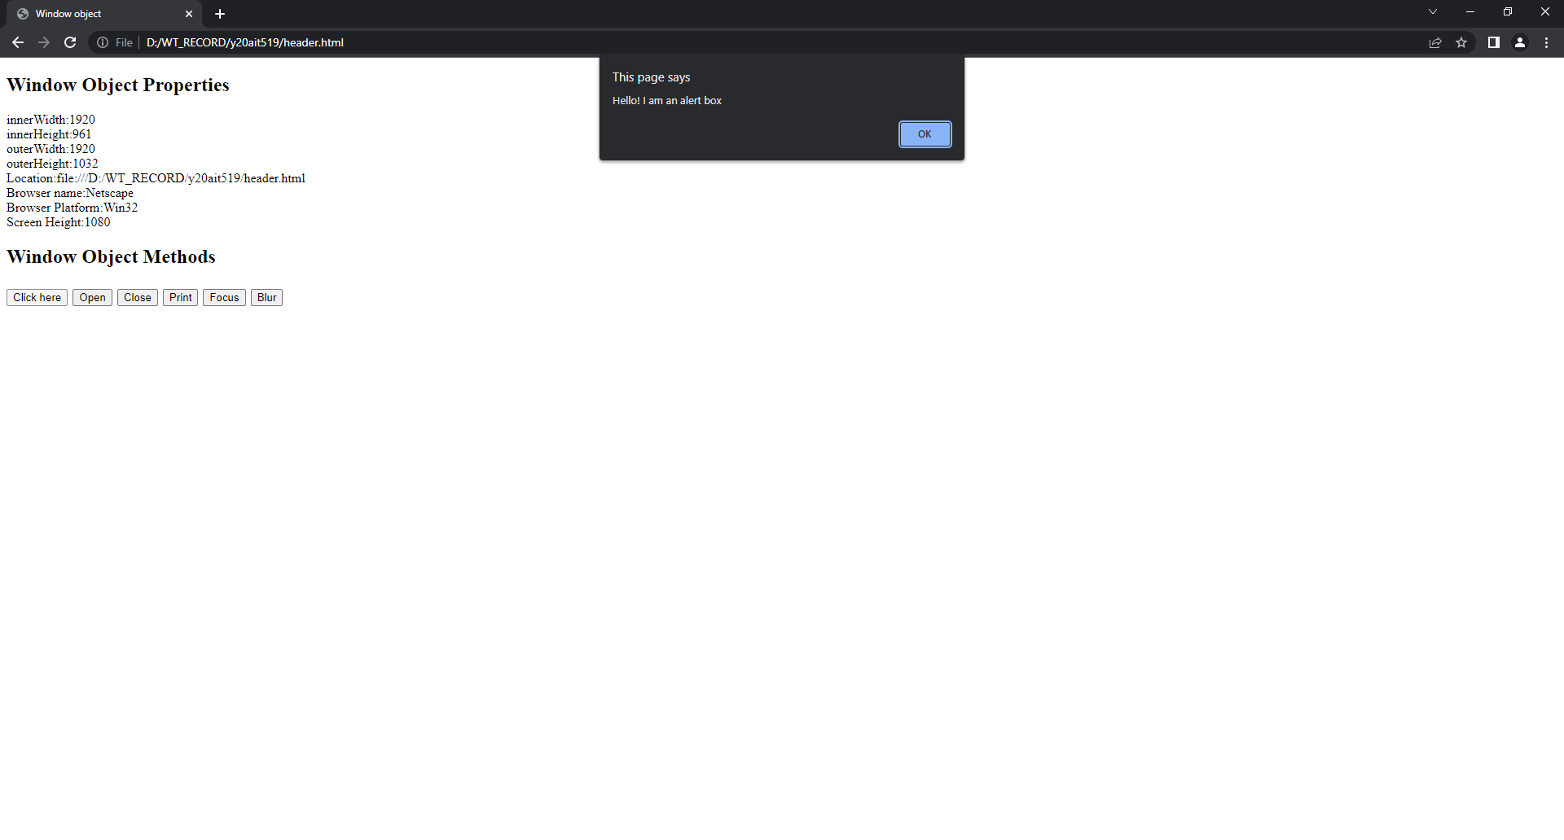

**Set timeout interval:**

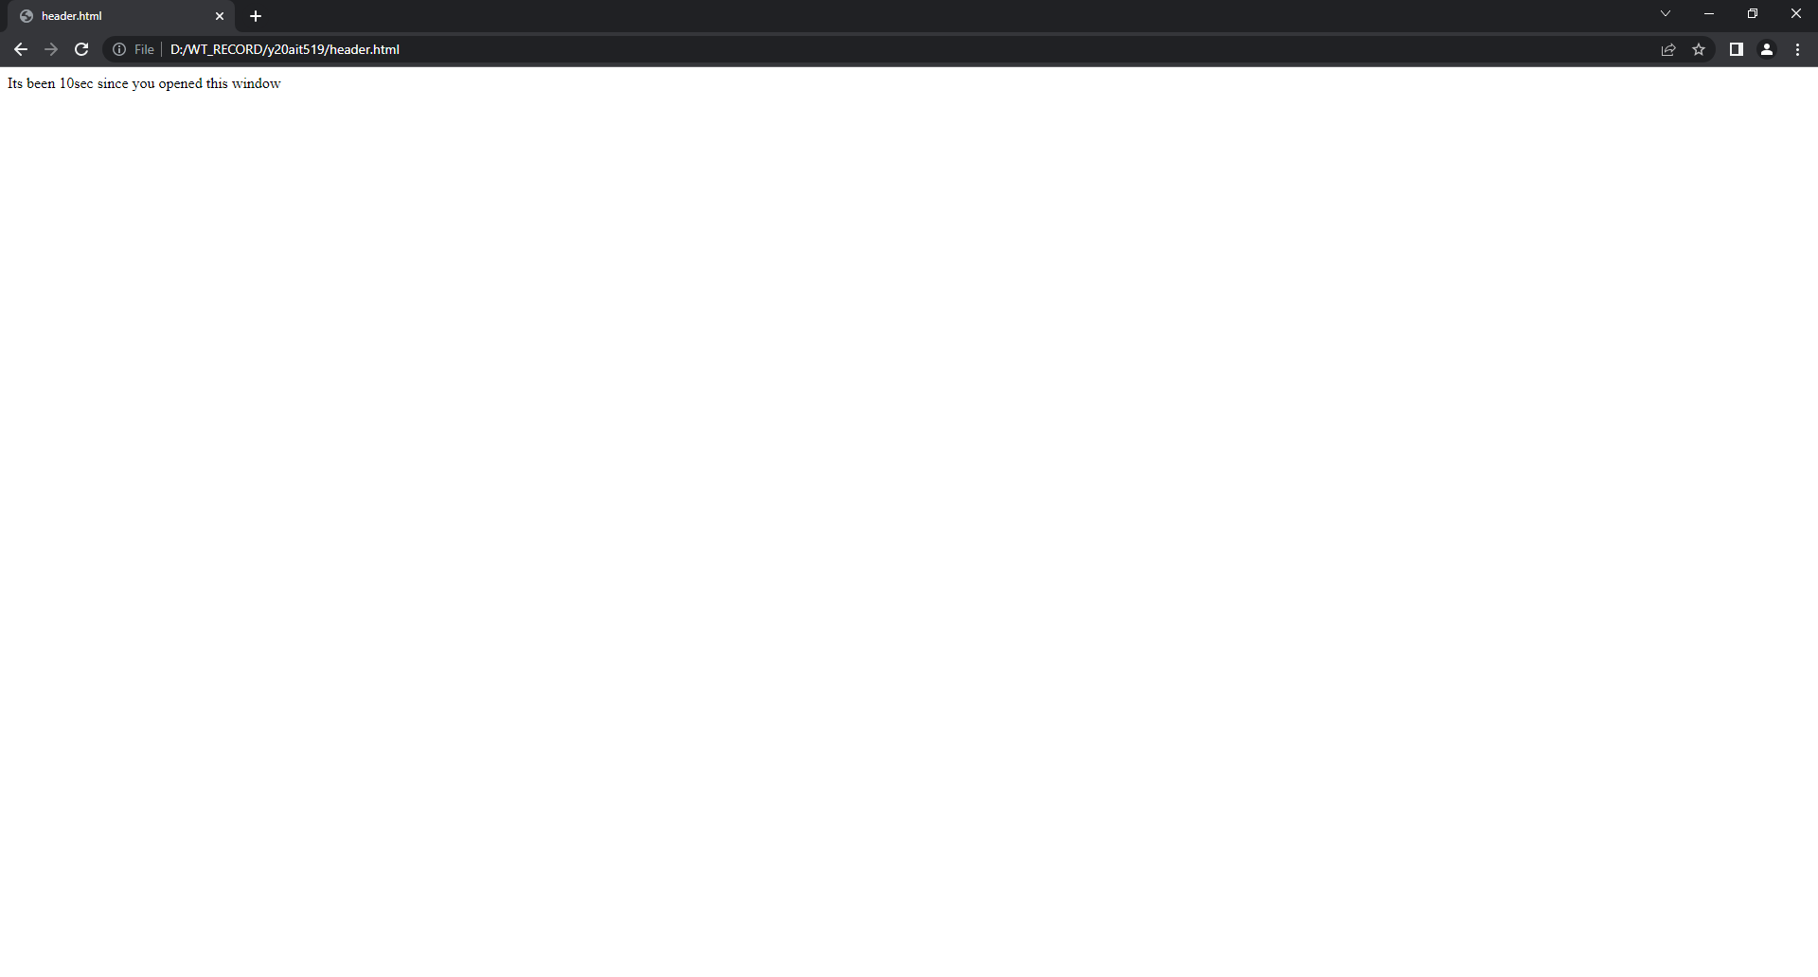

**Open a new window:**

**Print the window:**

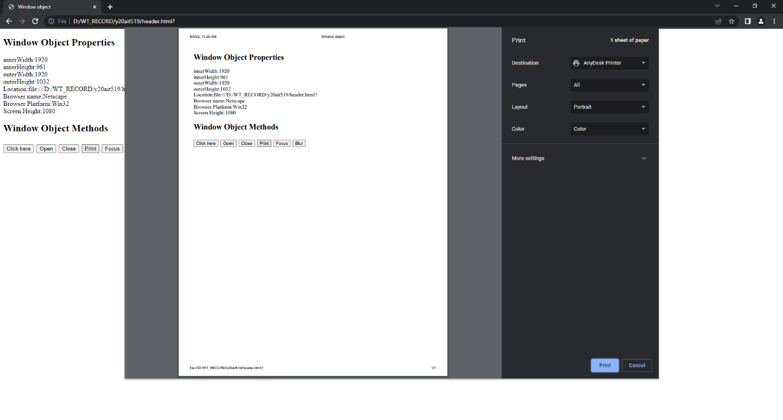

**7. ii) Aim: To write a JavaScript program to demonstrate Document Object.**

**Source code:**

<!DOCTYPE html>

<html>

<head>

<title>Document Object</title>

</head>

<body>

<h4>Images</h4>

<img src="logo.jfif" width="100px" height="100px">

<img src="bec.jpg" width="100px" height="100px">

<h4>links</h4>

<a href="List1.html">link 1</a><br>

<a href="Links.html">link 2</a>

<h3>Document Object Methods</h3>

<button onclick="opendocument()">Open Document</button>

<script type="text/javascript">

function opendocument(){

document.open();

document.write("<h1>Welcome to new Document</h1>");

document.close();

}

document.write("<h3>Document Object Collection</h3>")

document.write("no. of images = "+document.images.length);

document.write("<br>no. of links = "+document.links.length);

document.write("<h3>Document Object Properties</h3>");

document.write("Name of the document : "+document.title);

document.write("<br>URL of the document : "+document.URL);

document.write("<br>State of the document : "+document.readyState);

</script>

</body>

</html>

**Output:**

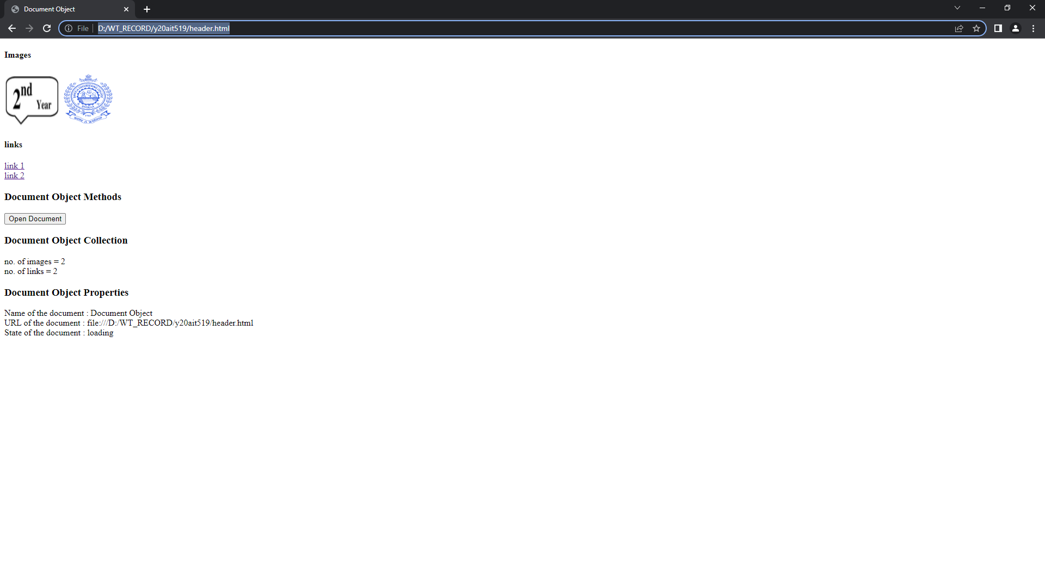

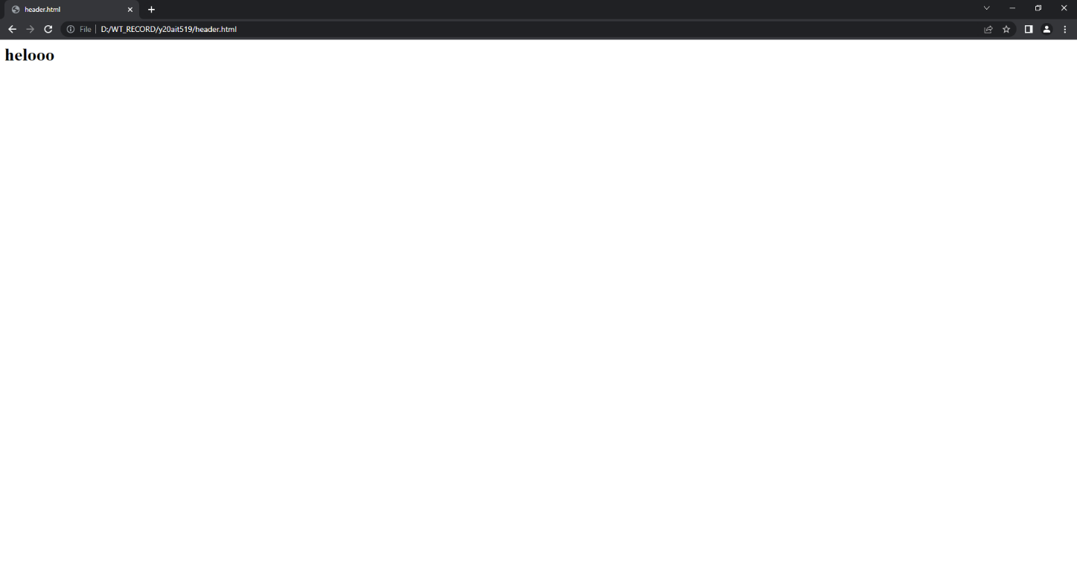

**8.a) Aim: Write a JavaScript program to create, delete, duplicate and insert the node before element using DOM node interface.**

**Source code:**

<!DOCTYPE html>

<html>

<head>

<title>Document object</title>

<script type="text/javascript">

function create_node(){

var link=document.createElement("a");

link.setAttribute("id","li");

link.setAttribute("href","nature.jpg");

link.setAttribute("width","100");

link.setAttribute("height","100");

text=document.createTextNode("My Link");

link.appendChild(text);

document.body.appendChild(link);

}

function delete_node(){

Child=document.getElementById("li");

document.body.removeChild(Child);

}

function clone_node(){

link=document.getElementById("li");

c=link.cloneNode(true);

document.body.appendChild(c);

}

function insert_node(){

link=document.getElementById("li");

para=document.createElement("p");

para.setAttribute("id","p1");

text=document.createTextNode("My Paragraph before link");

para.appendChild(text);

document.body.insertBefore(para,link);

}

</script>

</head>

<body>

<div id="d">

<h2>Node intereface methods</h2>

<button onclick="create_node()">create Link</button>

<button onclick="delete_node()">remove Link</button>

<button onclick="clone_node()">clone Link</button>

<button onclick="insert_node()">Insert paragraph before Link</button>

</div>

</body>

</html>

**Output:**

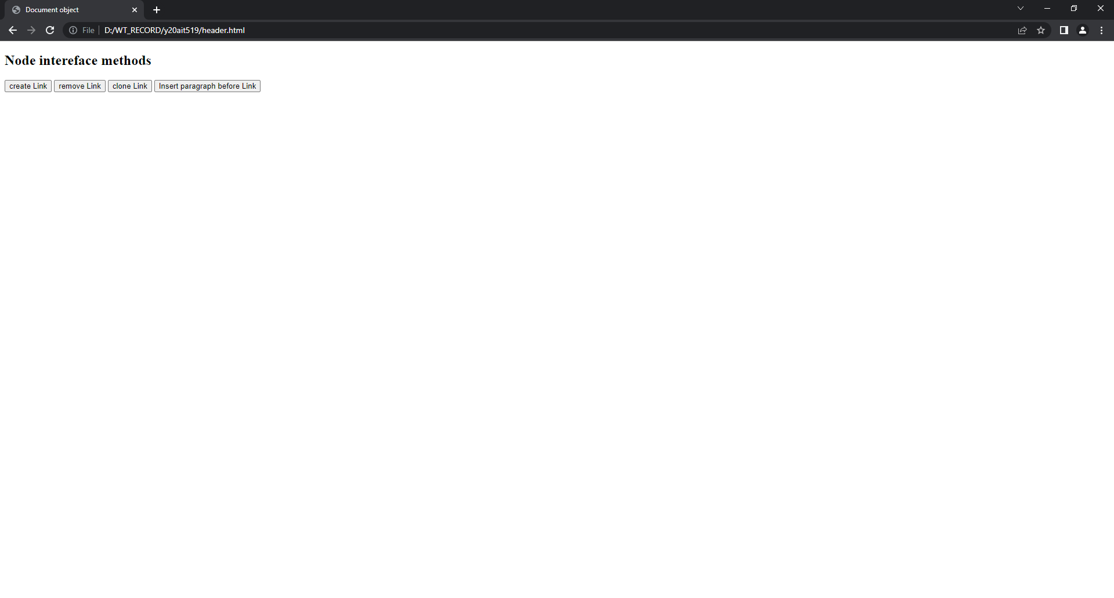

**Add link:**

**Clone link:**

**Insert link:**

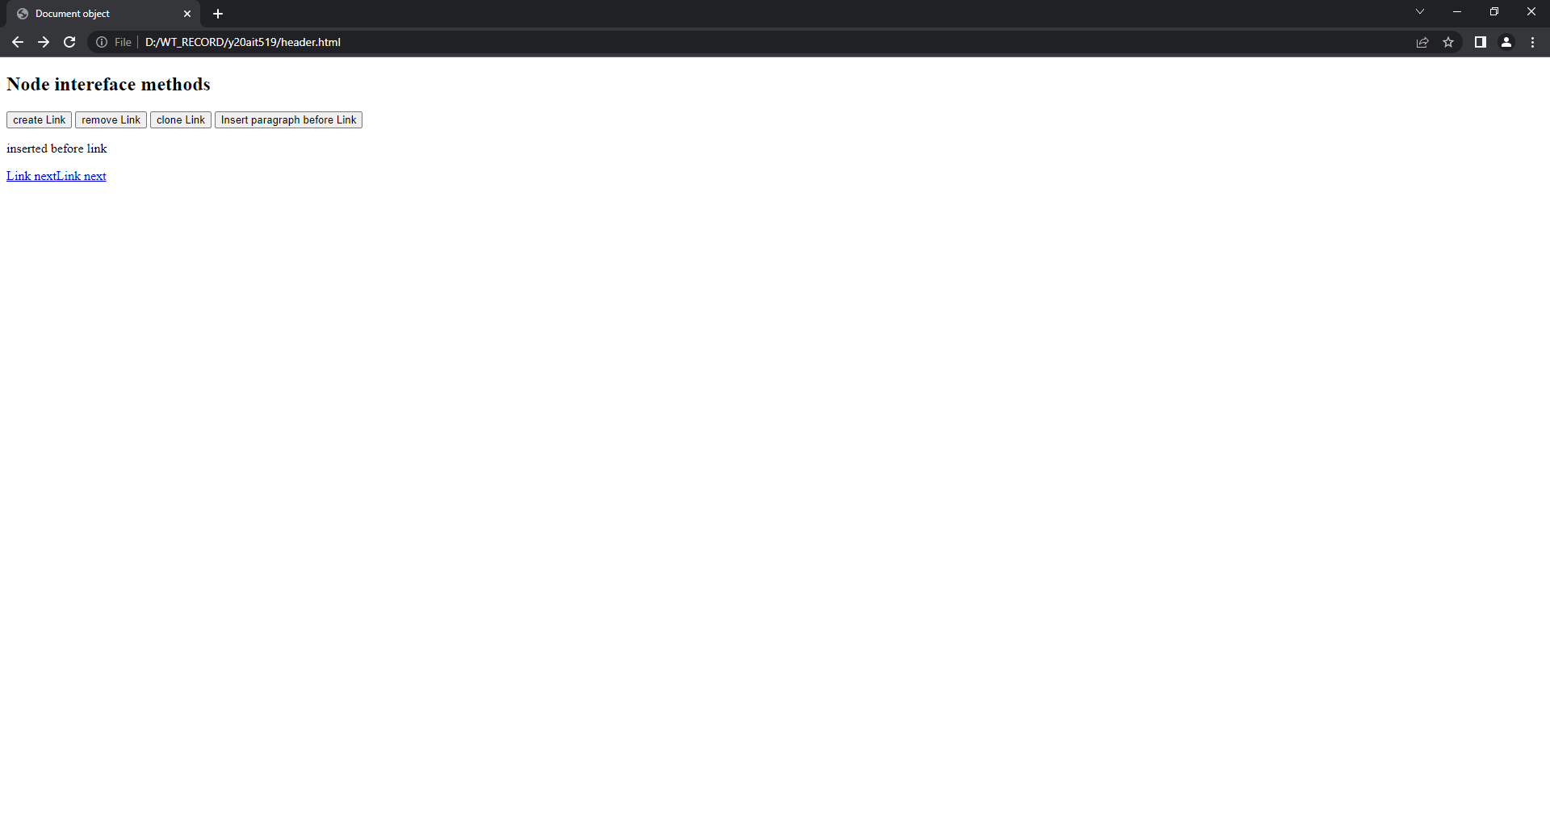

**Remove link:**

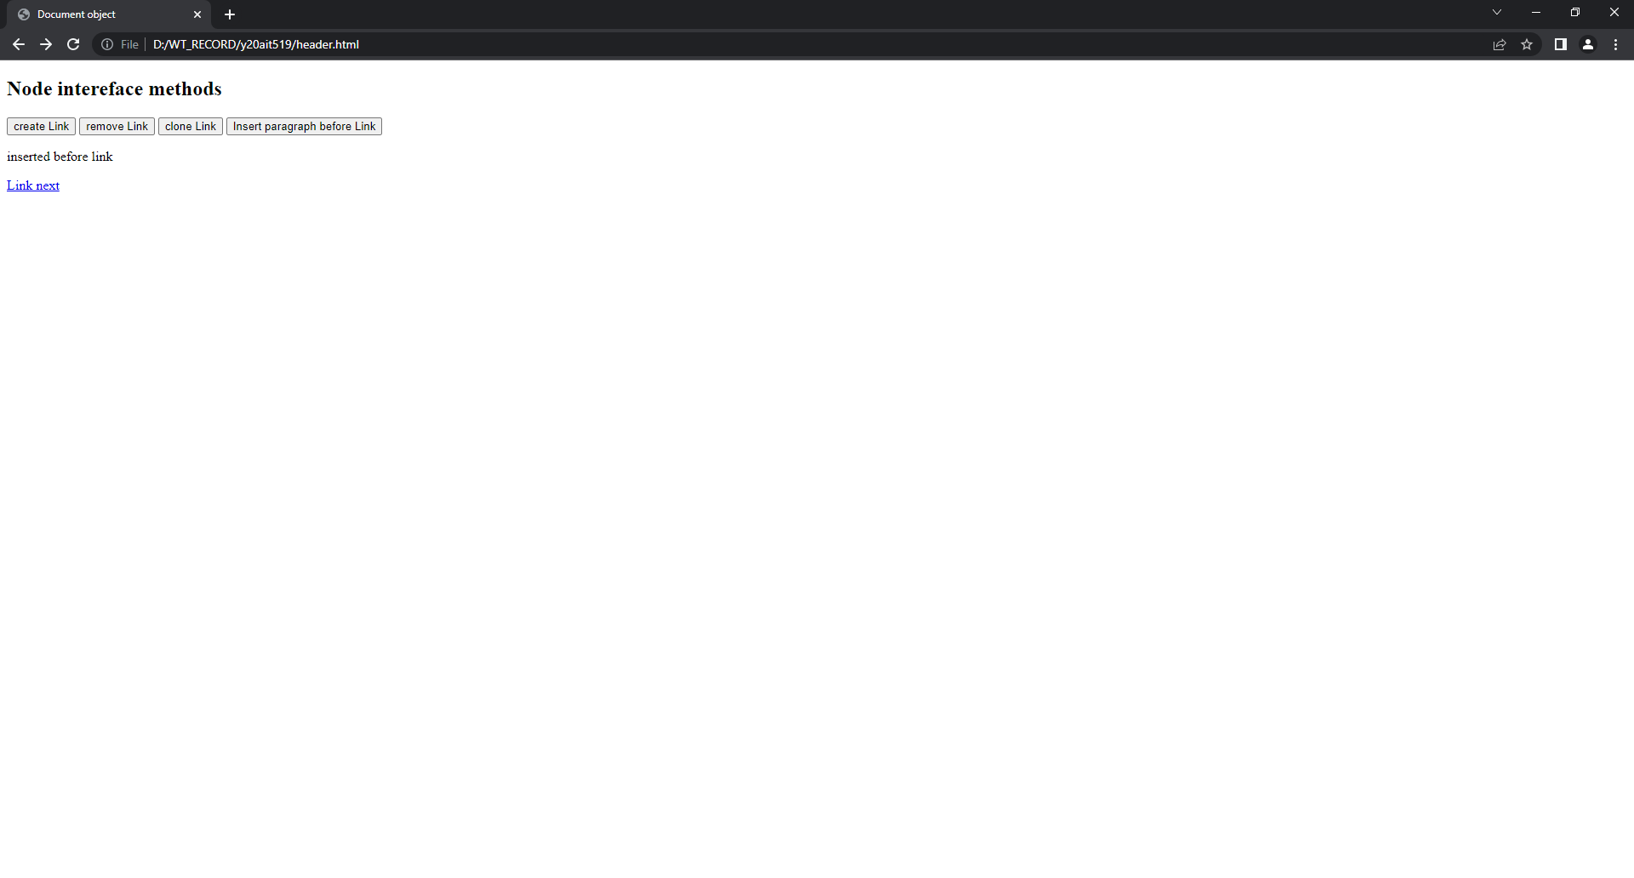

**8.b) Aim: To develop a simple web application calculator.**

**Source code:**

<!DOCTYPE html>

<html>

<head>

<title>Calculator</title>

<script>

function display(v){

val=document.getElementById("inp").value;

val=val+v;

document.getElementById("inp").value=val;}

function clear(){

document.getElementById("inp").value="";}

function operation(){

val=document.getElementById("inp").value;

res=eval(val)

document.getElementById("inp").value=res;}

</script>

</head>

<body>

<table border="2px">

<tr>

<td colspan="4"><input type="text" id="inp" style="text-align:right"></td>

</tr>

<tr style="text-align:center">

<td><button type="text" onclick="display('7')">7</button></td>

<td><button type="text" onclick="display('8')">8</button></td>

<td><button type="text" onclick="display('9')">9</button></td>

<td><button type="text" onclick="display('*')">*</button></td>

</tr>

<tr style="text-align:center">

<td><button type="text" onclick="display('4')">4</button></td>

<td><button type="text" onclick="display('5')">5</button></td>

<td><button type="text" onclick="display('6')">6</button></td>

<td><button type="text" onclick="display('-')">-</button></td>

</tr>

<tr style="text-align:center">

<td><button type="text" onclick="display('1')">1</button></td>

<td><button type="text" onclick="display('2')">2</button></td>

<td><button type="text" onclick="display('3')">3</button></td>

<td><button type="text" onclick="display('+')">+</button></td>

</tr>

<tr style="text-align:center">

<td><button type="text" value="delete" onclick="clear()">C</button></td>

<td><button type="text" onclick="display('0')">0</button></td>

<td><button type="text" onclick="display('.')">.</button></td>

<td><button type="text" onclick="operation()">=</button></td>

</tr>

</table>

</body>

</html>

**Output:**

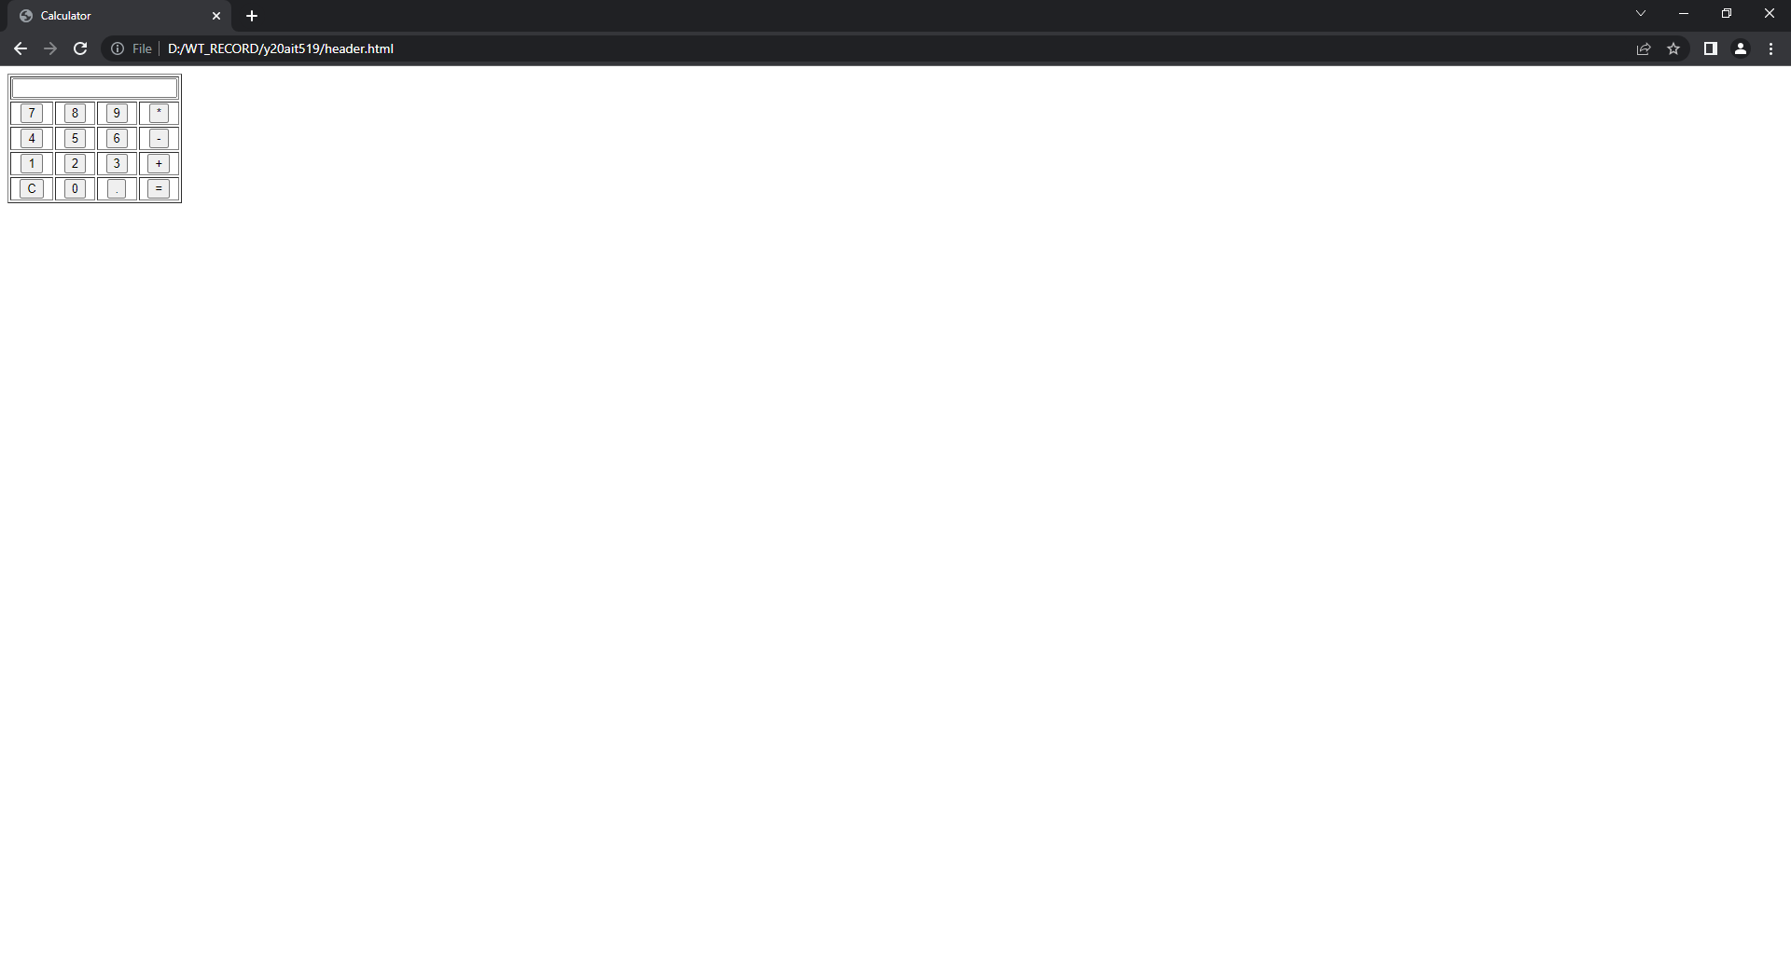

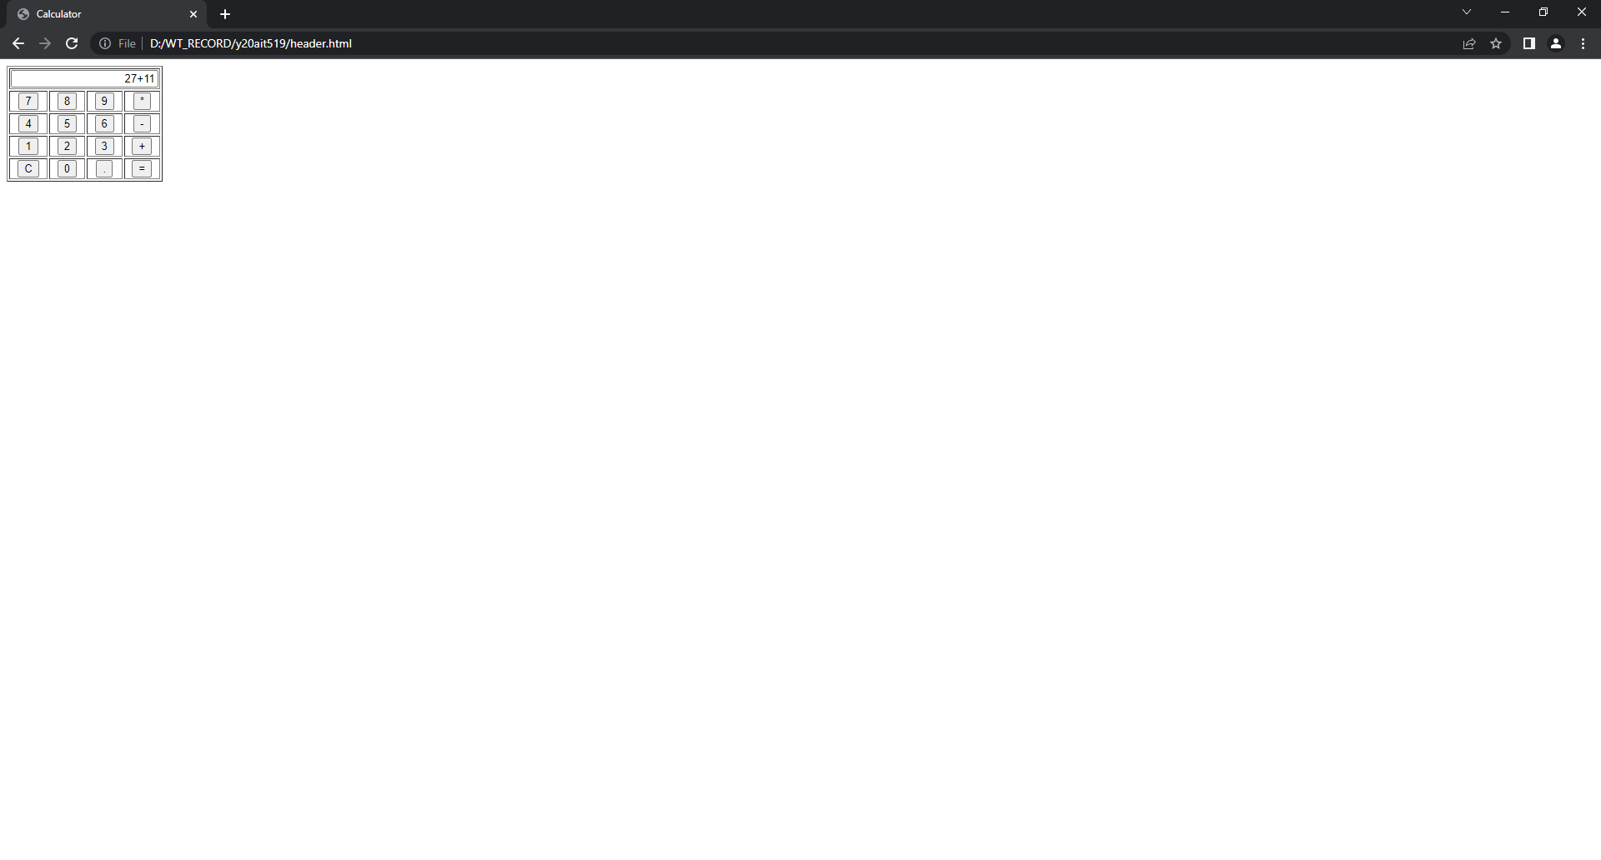

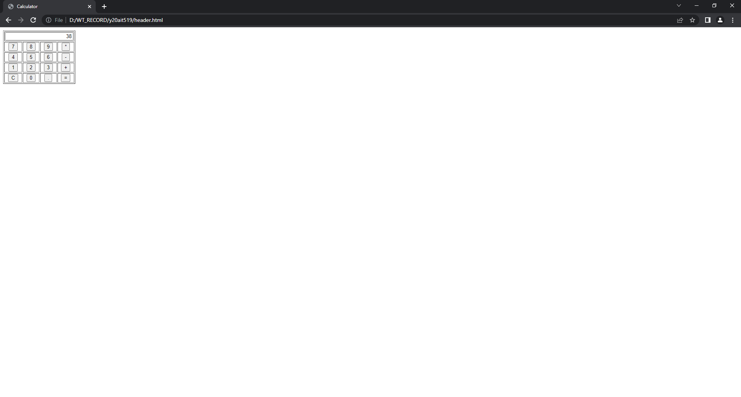

**9.a) Aim: To design a webpage to demonstrate Internal DTD**

**Source code:**

<?xml version="1.0"?>

<!DOCTYPE student[

<!ELEMENT student (name,regd,addr)>

<!ELEMENT name (#PCDATA)>

<!ELEMENT regd EMPTY>

<!ATTLIST regd id CDATA "408">

<!ELEMENT addr (dno,str,city)>

<!ELEMENT dno (#PCDATA)>

<!ELEMENT str (#PCDATA)>

<!ELEMENT city (#PCDATA)>

]>

<student>

<name>Akhil</name>

<regd id="519"/>

<addr>

<dno>4-63</dno>

<str>Mukundapuram</str>

<city>Nellore</city>

</addr>

</student>

**Output:**

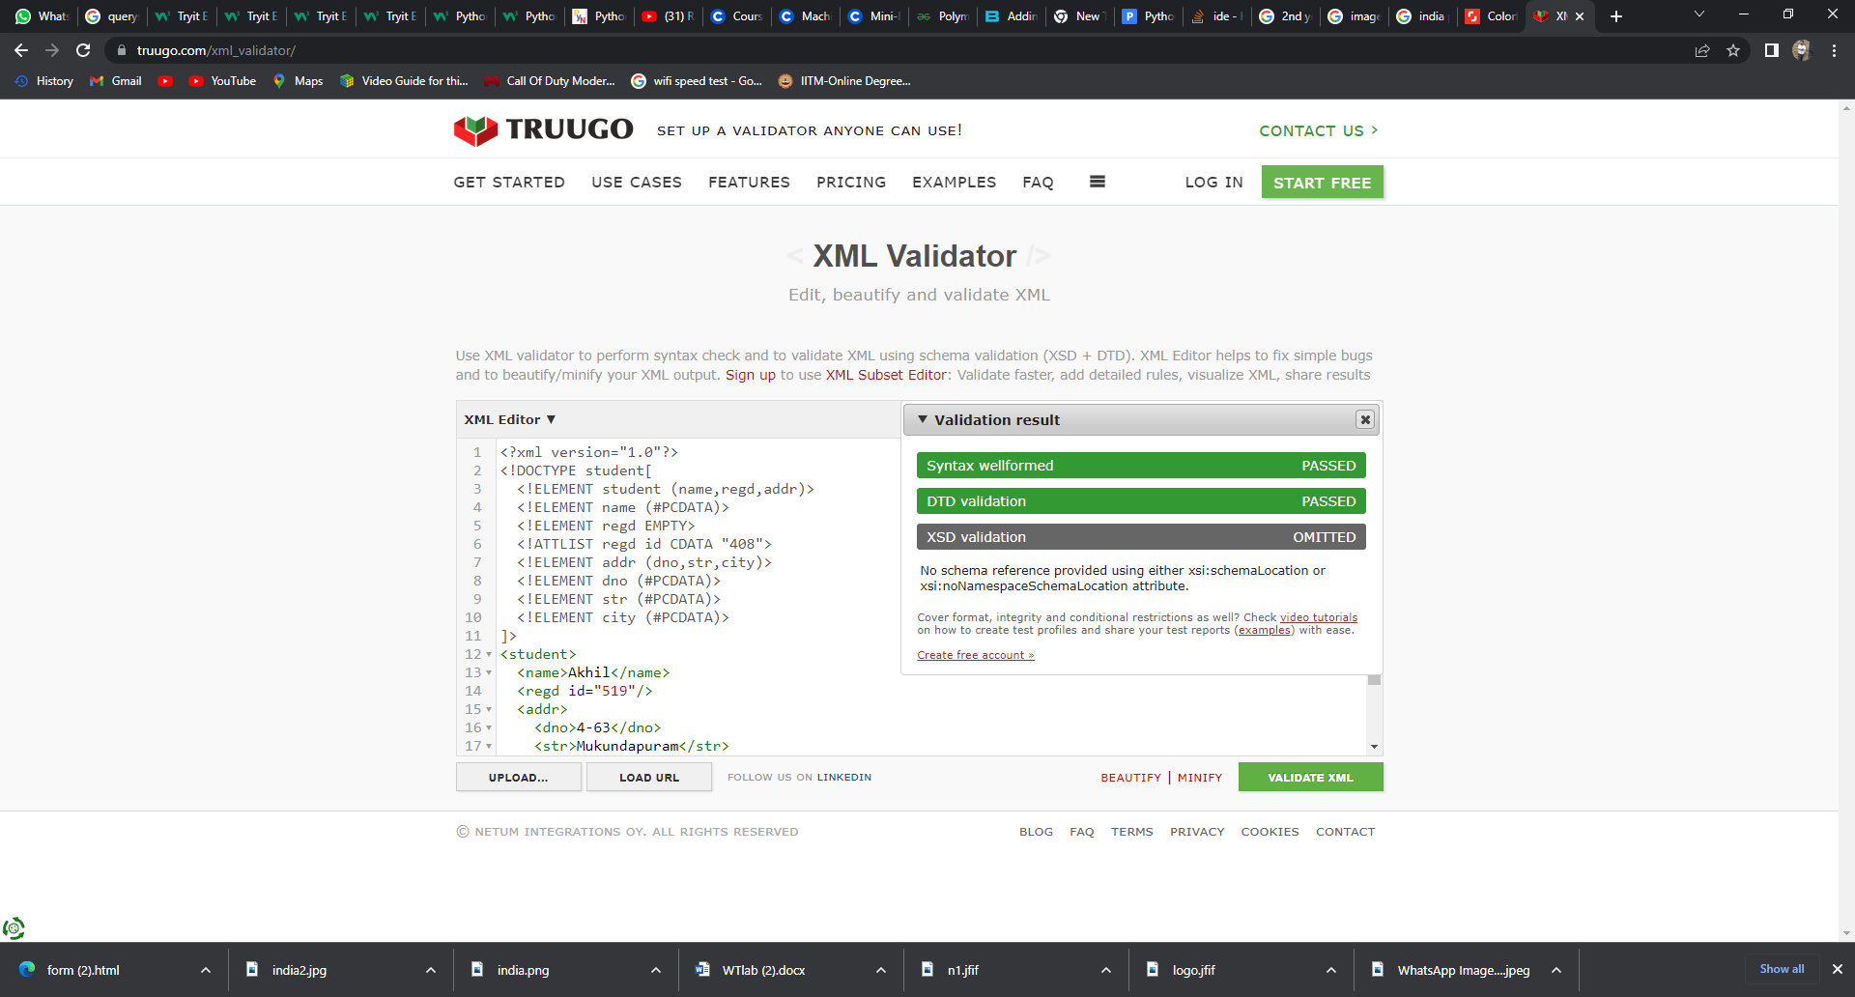

**9.b) Aim: To design a webpage to demonstrate External DTD.**

**Source code:**

**Student.dtd:**

<?xml version="1.0"?>

<!DOCTYPE student[

<!ELEMENT student (name,regd,addr)>

<!ELEMENT name (#PCDATA)>

<!ELEMENT regd EMPTY>

<!ATTLIST regd id CDATA "Y20AIT401">

<!ELEMENT addr (dno,str,city)>

<!ELEMENT dno (#PCDATA)>

<!ELEMENT str (#PCDATA)>

<!ELEMENT city (#PCDATA)>

]>

**External.xml:**

<student>

<name>Mahesh babu</name>

<regd id="Y20AIT519"/>

<addr>

<dno>54/67</dno>

<str>JUBLIEE HILLS</str>

<city>HYDERABAD</city>

</addr>

</student>

**Output:**

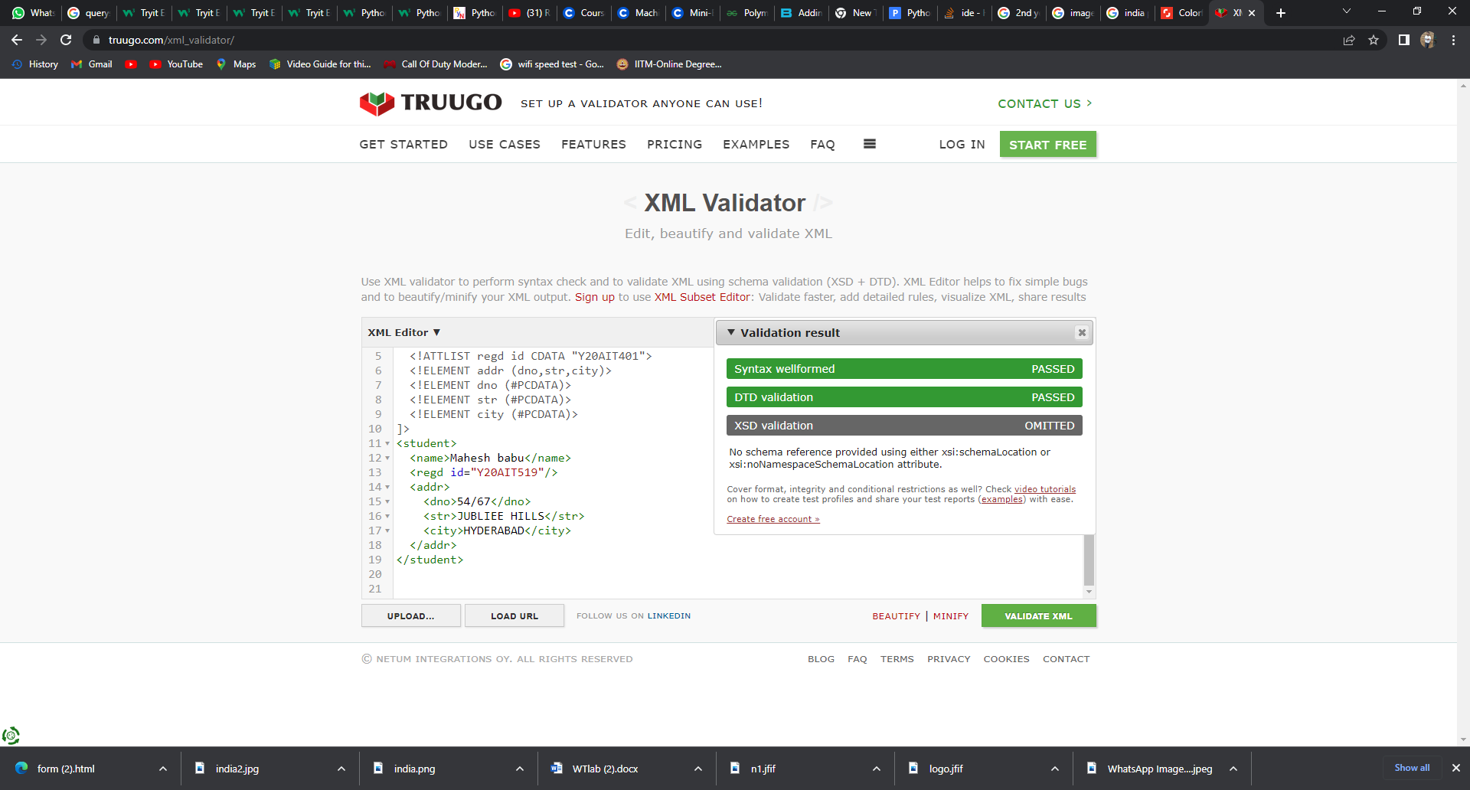

**10.Aim: Create an XML file to store the student data and validate using XSD.**

**Source code:**

**Student.xml**

<?xml version="1.0"?>

<student branch="IT">

<name>justin bieber </name>

<regd >"Y20AIT408"</regd>

</student>

**Student.xsd:**

**<?xml version="1.0"?>**

**<xs:schema xmlns:xs="http://www.w3.org/2001/XMLSchema">**

**<xs:element name="student">**

**<xs:complexType>**

**<xs:sequence>**

**<xs:element name="name" type="xs:string"/>**

**<xs:element name="regd" type="xs:string"/>**

**</xs:sequence>**

**<xs:attribute name="branch" type="xs:string"/>**

**</xs:complexType>**

**</xs:element>**

**</xs:schema>**

**Output:**

